2025-26 Supporting Women in Business Grants
  - Frequently Asked Questions
Last updated: July 2025

Contents
1 Overview of the Grant 3
2 Selection criteria 3
3 Application process 4
4 Assessment process 5
5 Successful grant applications 5

These Frequently Asked Questions are designed to help organisations and groups that wish to apply for the 2025-26 Supporting Women in Business Grants. Please read these in combination with the Program Guidelines and online application form in SmartyGrants.

Overview of the Grant
What is the aim of the Supporting Women in Business Grants?
The aim of the Supporting Women in Business Grants (SWIB) is to connect women in small business or who are looking to start or grow a small or micro business with the right resources and support.
The grants seek to increase women’s skills and confidence and to support women in achieving their business goals. A range of tailored projects will be supported, from training, mentoring, networking skills and opportunities, assistance to access finance and business development support.
Projects will be targeted to the nominated focus communities, responding to their specific needs and circumstances.
How long has SWIB been running?
This grant was launched as part of the Women’s Economic Opportunity Statement under the NSW 2022-23 Budget initially as Women in Business Networks grants. A list of previous recipients is on the Women NSW website.
What benefits does the grant provide for women?
Some of the benefits include:
- Increased economic participation by women as entrepreneurs, sole traders, business owners and leaders.
- Women experience reduced barriers to starting and growing a business.
- The role, status and contribution of women and girls in our communities are strengthened.
- Enhancements in business turnover and/or profit, along with the potential for increased employment opportunities.
- Improved financial wellbeing and greater economic security due to the successful initiation or growth of their businesses.
Is there a co-contribution requirement for applicant?
Yes, a minimum financial co-contribution of 10 per cent is required. This contribution can be in cash or in-kind.

Selection criteria
What can SWIB grant funds be used for?
Grant funding can only be used for expenses directly related to the delivery of the project in NSW. Applicants must clearly set out proposed expenditure in the application and outline how the project will demonstrate value for money. A list of ineligible items for expenditure are in the SWIB Guidelines.
What if I include something that is ineligible in my budget?
An application will be ineligible if the budget includes ineligible items.
Is there a specific plan required for monitoring and evaluation?
Yes, an Evaluation Plan is required as the first deliverable for the project if the application is successful. Guidance for preparing applications and evaluation can be found in the Guidelines.
What does it mean for projects to be evidence-based?
Applicants must demonstrate that their proposed model effectively addresses barriers to small business ownership for the focus community and achieves program outcomes based on solid evidence.
If your solution lacks strong evidence, you should demonstrate relevant experience, practice wisdom, and correlations with evidence from other areas to support your proposal. A non-exhaustive list of sources of evidence can be found in the Guidelines.
What areas are considered regional versus metropolitan in NSW?
NSW regional, rural, remote and cross border areas of NSW areas are defined as all local government areas of NSW outside the metropolitan areas of Greater Sydney, Newcastle and Wollongong - as illustrated in the Regional and Metropolitan boundaries maps below:
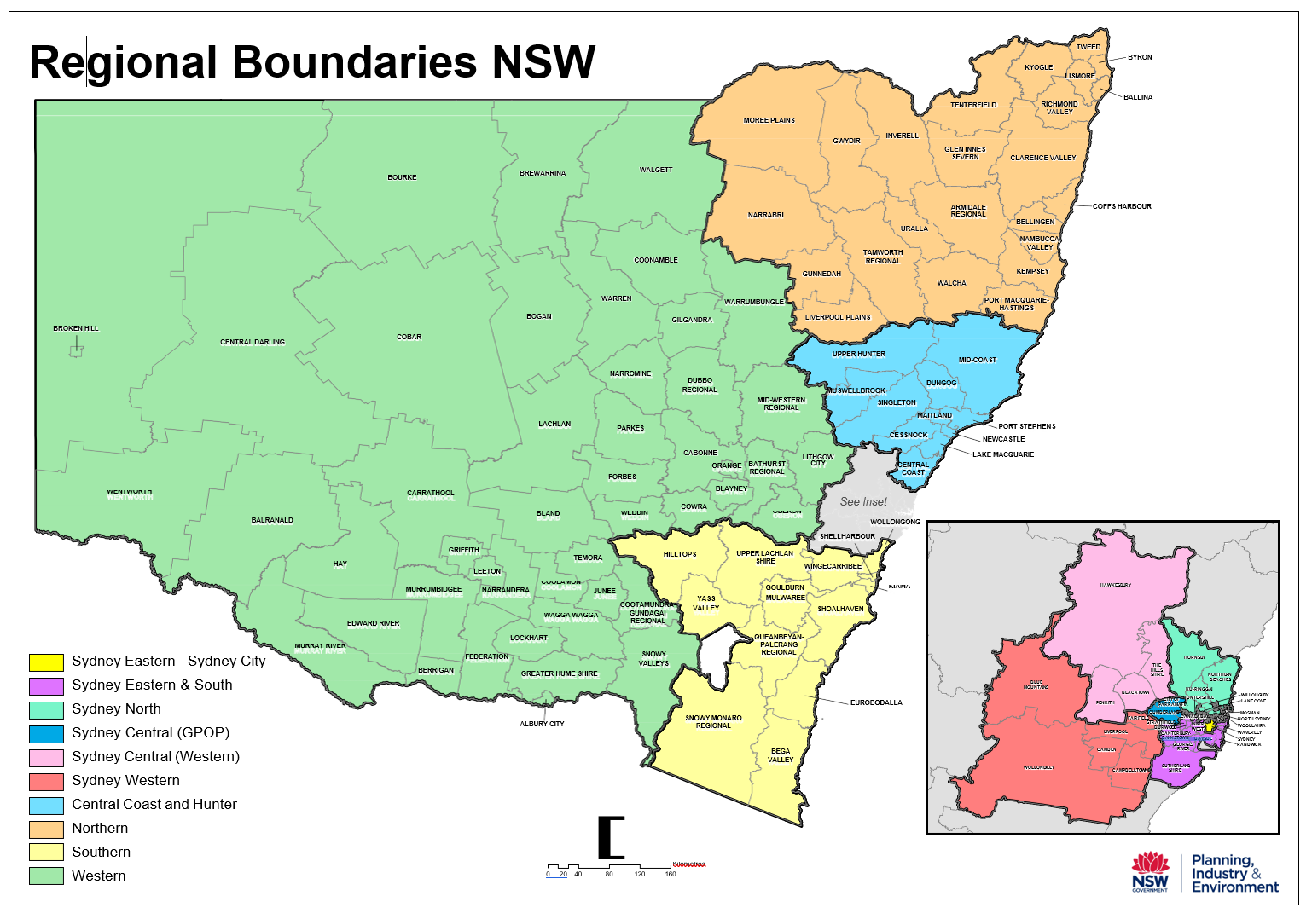 | 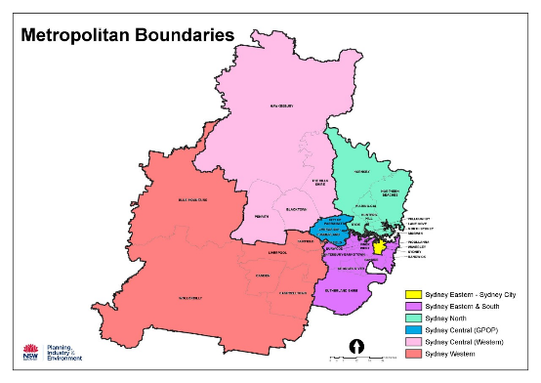

Application process
How many applications can an organisation submit?
Eligible organisations can submit only one application.
Is it possible for the same organisation to apply for both SWIB and other Women NSW grants?
Yes, the same organisation can apply to other Women NSW grant programs, provided they meet the eligibility criteria for each grant. Applicants should carefully review the specific guidelines for both programs to ensure they meet all requirements.
Only one application per organisation will be accepted for SWIB.
Can an application that has been submitted be revised?
Yes, a submitted application can be reopened upon request until the closing date. To reopen a submitted application, email wnswgrants@tco.nsw.gov.au before the closing date.
Late applications will not be accepted.
What is SmartyFile and what does it allow you to do?
You have the option to create a SmartyFile profile for your organisation. SmartyFile allows organisations to collaborate with team members, pre-fill information into forms and manage, view, search, and sort submissions across multiple funders in one spot. To learn more, go to About SmartyFile.

Assessment process
What happens if an application is deemed ineligible?
Any application deemed “ineligible” will not proceed to the next stage of the assessment.
How will applicants be notified of the outcome of their application?
All applicants will be advised of their application outcome in writing through the SmartyGrants portal. Notification will also make clear how and when grants will be announced publicly.
Announcements will not be made regarding grants awarded before the grantee has been informed.

Successful grant applications
What happens if I am successful?
Grant recipients are required to enter into a funding agreement with The Cabinet Office. Organisations funded by The Cabinet Office must operate in accordance with their funding agreement and with legislation, policies, and guidelines relevant to their project funding. Successful grantees are required to sign and return their funding agreement within two weeks of receipt.
What documentation is required for the Funding Agreement?
Incorporated Associations will be required to provide a copy of the resolution or delegation confirming that the signatories have the authority to execute a Deed or Contract on behalf of the Association.
Australian Public Companies will be required to provide evidence confirming your corporate legal structure by way of a paid ASIC extract. ASIC Company Extracts can be purchased online using a credit card on the ASIC website at a cost of $10.
Important terms and conditions associated with the funding are attached to the funding agreement.
When and how will the grant funds be paid?
As part of the funding agreement an invoice template is provided. Once the funding agreement has been executed by all relevant parties and the correct invoice received, the grant funds will be paid to the nominated bank account and a copy of the executed document will be emailed.
Can I announce publicly that I was successful?
Grant recipients should not make public announcements about their project without prior approval from Women NSW. Once you have been notified that the grant is no longer under embargo, you can communicate the outcomes of the grant.
What if I want to change something about my project?
Any variations to the funding agreement, including project scope or activities, location or timeframes outlined in the application form and grant program guidelines must be submitted in writing for approval from Women NSW. Failure to request a variation to the funding agreement in writing so may result in the withdrawal of the grant offer.
What if I need to use the funding for something other than the project?
Organisations must not use the money provided for the project, nor any interest earned on the money, for any other purpose beyond what is specified in the approved submitted application.
Organisations must not carry over funds provided for the approved project, to other programs, events, or organisational operating budgets. All grant monies are required to be spent on the approved project or the funds must be returned.

