The Cabinet Office

Supporting Women in Business Grants Guidelines
  - 2024-25 Guidelines
December 2024

Acknowledgement of Country
The Cabinet Office acknowledges the Traditional Custodians of the lands where we work and live. We celebrate the diversity of Aboriginal peoples and their ongoing cultures and connections to the lands and waters of NSW.
We pay our respects to Elders past, present and emerging and acknowledge the Aboriginal and Torres Strait Islander people that contributed to the development of this guidelines for the Supporting Women in Business grants.
We advise this resource may contain images, or names of deceased persons in photographs or historical content.

Supporting Women in Business Grants Guidelines
Published by Women NSW, The Cabinet Office
First published: October 2024

Copyright and disclaimer
© State of New South Wales through The Cabinet Office 2024. Information contained in this publication is based on knowledge and understanding at the time of writing, October 2024, and is subject to change. For more information, please visit https://www.nsw.gov.au/nsw-government/copyright.

Grant Program Details
EOI Application opening | 10:00 AEDT on 20 January 2025
EOI Application closing | 15:00 AEDT on 14 February 2025
Anticipated EOI outcome | By Week commencing 10 March 2025
Full Grant Application opening | 10:00 AEDT on 17 March 2025
Full Grant Application closing | ​​15:00 AEDT on 28 March2025​
Application outcomes advised | May 2025
Anticipated date for Funding Deed execution (with successful applicants) | May 2025
Project delivery timeframe (for successful applicants) | July 2025 – 30 June 2027
Decision-maker | ​​Minister for Women​
NSW Government Agency | ​​Women NSW, The Cabinet Office​
Type of grant opportunity | ​​Open, competitive​
Grant value (total available funding for the grant and the available individual grant amounts, excluding GST) | Total funding budget of $1.08 million.  Individual grant amounts from $150,000 to $250,000 (excluding GST) per applicant.
Enquiries | If you have any questions about the grant that are not covered in these funding guidelines, please contact Women NSW:  Email: WNSWGrants@tco.nsw.gov.au  For queries about the online grant management system, Smarty Grants, please contact the support team at:  Email: service@smartygrants.com.au  Phone: (03) 9320 6888  Available to help Monday to Friday 9:00am to 5:00 (Australian Eastern Standard time).
NB: The above dates are proposed only and are subject to change. The Cabinet Office (Women NSW) will notify applicants of any changes to timeframes and deadlines.

Contents
1 Overview of grants 1
1.1 Purpose and objectives 1
1.2 Grant value 1
1.3 Focus communities 1
1.4 Projects 2
1.5 Intended outcomes 3
2 Selection criteria 3
2.1 Eligibility criteria 3
2.1.1 Requirements for Aboriginal / Torres Strait Islander Community-Controlled Organisations 4
2.1.2 Requirements for Not for Profits: 4
2.1.3 Requirements for social enterprises 5
2.2 Ineligible Applicants 5
2.3 NSW National Redress Scheme sanctions 5
2.4 Eligible and ineligible uses of funding 6
2.4.1 Items eligible for grant expenditure: 6
2.4.2 Items not eligible for grant expenditure: 6
2.5 Assessment criteria 7
2.5.1 Expression of Interest assessment criteria 7
2.5.2 Application Assessment criteria 7
2.6 Project evaluation 9
2.7 Evidence requirements 9
3 Expression of Interest and Application process 10
3.1 How to apply 10
3.1.1 Stage One - Expression of Interest Application 10
3.1.2 Stage Two – Full Grant Application 10
3.1.3 Support for Applicants 11
4 Assessment process 12
4.1 Stage One – Expression of Interest Application 12
4.2 Stage Two – Full Grant Application Assessment 12
4.3 Stage Three – Assessment Panel recommendations 12
4.4 Notification of application outcome 12
4.5 Feedback on applications 13
4.6 Publication of grants information 13
5 Successful grant applications 13
5.1 Variations to the approved funding activity 14
5.2 Unspent funds 14
5.3 Advertising and promotion 14
5.4 Reporting and acquittal requirements 14
5.5 Insurance 15
6 Additional information and resources 15
6.1 Disclaimer 15
6.2 Complaint handling 15
6.3 Access to information 15
6.4 Conflict of interest management 16
6.5 Confidentiality 16
7 Appendix 16
Appendix A – SWIB Project Logic template 16
Appendix B - Sources of evidence 16
Appendix C - Guidance on preparing an application and evaluation 17
Appendix D – NSW Regions 17

Overview of grants

Despite the prevalence of small businesses in New South Wales, only one-third of these businesses are owned by women. While there is evidence new small businesses in Australia are increasingly women-led, the number of women-led businesses remains significantly lower than male-led businesses.
The Supporting Women in Business Grants (SWIB) was established by the NSW Government in 2023 to connect women in small business or looking to start a small business with the right resources and support to successfully start or grow a micro or small business. The SWIB program delivers on NSW Government priorities including the NSW Women's Strategy 2023 - 2026.
Women NSW will seek an Expression of Interest (EOI) from organisations seeking to deliver SWIB projects. Organisations can submit one EOI only. The EOI form will be simpler and shorter to complete than an application form.
A shortlist of organisations outlining SWIB projects that clearly demonstrate how your proposed project will deliver outcomes for women from focus communities and value for money will then be invited to complete the more detailed full grant application form through SmartyGrants.
Women NSW encourages applicants to read all the details in these guidelines before applying. Women NSW have a responsibility to make sure projects provide value for money. It is important you are able to demonstrate how your proposed project provides outcomes and how the grant will deliver value for money.

Purpose and objectives
The primary objective of SWIB is to address barriers and support women to achieve their purpose of starting or growing a micro or small business.
A variety of tailored projects will be funded, to provide support, training, mentoring, networking skills and opportunities, support to access finance and business development support. Projects will be targeted to the nominated focus communities, responding to their specific needs and circumstances.

Grant value
The total budget allocation of the 2024-25 SWIB grants is $1.08 million. SWIB grants are for one-off funding only, for grants between $150,000 to $250,000 each.
A minimum of 10% financial co-contribution is required. This can be cash or in-kind sources.
Only one application for funding will be accepted per organisation.

Focus communities
The target group for the SWIB grants is women who face enduring and complex barriers to economic participation. Projects must target and support one of the following focus communities from the NSW Women’s Strategy 2023-2026.
Focus communities:
- Aboriginal and Torres Strait Islander women
- carers
- young women living in, or who have lived in, out-of-home care
- lesbian, gay, bisexual, trans, intersex, queer and/or asexual (LGBTIQA+) women
- older women
- women and girls experiencing socioeconomic disadvantage
- women facing homelessness
- women from culturally and linguistically diverse (CALD) communities
- women in contact with the criminal justice system
- women living in regional, rural, remote and cross-border areas
- women with disability
- women with a mental illness
- women who have a history of, or are currently experiencing, domestic, family or sexual violence
- women veterans (and the women partners of veterans and service members)
- young women (17-24)
Consideration is made based on a distribution of projects across focus communities and geographic spread.
Regional, rural, remote and cross border areas are defined as local government areas (LGAs) of NSW outside the metropolitan areas of Greater Sydney, Newcastle and Wollongong, as illustrated on the regional and metropolitan boundaries maps at Appendix D.

Projects
SWIB will fund a variety of models and funding will vary according to the proposed model and corresponding extent of services to be provided, in response to focus communities’ needs.
Projects should provide a model delivering some or all the following components. A minimum of four service components is required. Supports can include, but are not limited to the following:
Key components | Examples of supports / services
Accelerator programs | Short term accelerator programs supporting female founders at any stage of their business through mentoring and access to finance.
Coaching and mentoring | Tailored mentoring and support programs and business support to help participants start, run and grow their small business.
Small business training / workshops | Provide online or in-person training workshops and support access to a range of relevant accredited training options to increase required business skills.
Advisory services including support with business planning | One-to-one tailored business advisory sessions supporting participants with starting a micro / small business or operating an existing business. Includes supporting participants to develop a business plan and reviewing viability.  Advice on a range of other small business matters including (but not limited to) finance, operations, marketing and promotions, customer / client management, governance or administration.  Support participants to develop procurement readiness in order to supply goods and services to government and other businesses, as relevant.  Connect participants with NSW Government and other business support services, as relevant.
Support in developing business networks | Support participants to link to relevant small business and industry networks and to build their networking skills for the purposes of business growth and increased access to finance.
Support in gaining access to finance, investment or start-up capital | Support participants to understand the types of finance available and which is best suited to their needs. Support participants to access finance.

Intended outcomes
SWIB outcomes are detailed in the Project Logic template at Appendix A. It is expected that SWIB projects will achieve a range of outcomes tailored to the specific needs and goals of the business owner.
Outcomes for participants will include:
- Increased access to resources and support in starting or growing a micro or small business
- Increased networks, business skills and confidence in starting or growing a business
- Access to finance, investment, or start-up capital to start or grow a business
- Increased number or size of small businesses run by participants within 12 months
- Higher business turnover, profit or employment
- Increased customer or client base and / or business growth, expansion, capacity and output
- Participants financial wellbeing and economic security are improved as a result of starting or growing a successful business
- Businesses run by participants have greater presence in existing markets and/or access to extended, alternate, or larger markets
- Increased number of women owned and led businesses registered to procure their services to the NSW Government via Buy NSW. Support will be provided to organisations regarding this outcome.

Selection criteria
Selection criteria for a grant comprises both eligibility and assessment criteria. EOIs are required to meet all the eligibility criteria and competitively address the assessment criteria.

Eligibility criteria
Applicants are required to meet all the eligibility criteria below:
- Applicants must be a legally constituted Australian-based entity from one of the following categories:
- Aboriginal and / or Torres Strait Islander Community Controlled Organisations (ACCO).
- Incorporated, not-for-profit organisations, including community organisations, industry associations, peak bodies and Chambers of Commerce
- Social enterprises
- Applicants must be willing to obtain appropriate public liability insurance (minimum of $10 million) if successful.
- Applications must provide a budget outlining proposed funding of eligible expenditure items and excluding non-eligible expenditure items (per section 2.3 in the guidelines). A minimum of 10 per cent funding from other sources (monetary or in-kind).
- An application must be made by a single organisation that will accept responsibility for the delivery of the project if the application is successful.
- Applicants must be based within NSW, unless they can demonstrate that the project will be run in and for the benefit of women and/or girls in NSW and that the organisation meets all regulatory, business requirements.
- Projects must be delivered in the period between July 2025 – 30 June 2027.Applicants must apply for funding within the specified amounts of $150,000 to $250,000.

Requirements for Aboriginal / Torres Strait Islander Community-Controlled Organisations
For the purpose of this grant, an eligible Aboriginal and / or Torres Strait Islander Community Controlled Organisation builds the strength and empowerment of Aboriginal and Torres Strait Islander communities and people, and is:
- Incorporated under relevant legislation;
- Not-for-profit (see further requirements below);
- Controlled and operated by Aboriginal and / or Torres Strait Islander people;
- Connected to the community or communities in which they deliver services; and
- Governed by a majority Aboriginal and / or Torres Strait Islander governing body.
Applicants will be required to provide documentation to support their ACCO status such as:
- an Office of the Registrar of Indigenous Corporations certificate of registration,
- a constitution/rule book which shows the organisation requirements,
- letters or surveys from other local Aboriginal organisations, groups or relevant community stakeholders or outcomes from community feedback.

Requirements for Not for Profits:
Eligible not-for-profit organisations must be registered and approved as a not-for-profit body with a current and up-to-date record in at least one of the following categories:
- Charities, trusts, and cooperatives that are registered with the Australian Charities and Not-for-profits Commission (ACNC).
- Organisations with Deductible Gift Recipient (DGR) status.
- Organisations with Public Benevolent Institution status.
- Associations (registered under the Associations Incorporation Act 2009 and with NSW Fair Trading).
- Non-distributing co-operatives registered under the Co-operatives National Law (NSW) and with NSW Fair Trading.
- A Local Aboriginal Land Council under the Aboriginal Land Rights Act 1983 (NSW) and registered with the NSW Aboriginal Land Council.
- Indigenous Corporations registered with the Office of the Registrar of Indigenous Corporations.

Requirements for social enterprises
To be considered a social enterprise, an organisation must satisfy each of the criteria below:
- be established with a social, cultural or environmental purpose consistent with a public and/or community benefit
- trade commercially to fulfil their purpose
- derive a substantial portion of their income from trading commercially
- reinvest the majority of their surplus in the fulfilment of their purpose
Social Traders certification or People and Planet First global verification is required as evidence to demonstrate the social enterprise definition is met. Organisations will be required to indicate which certification or verifications they will use at EOI and provide evidence at full application stage.

Ineligible Applicants
Funding will not be provided to:
- Individuals or groups of individuals, including sole traders.
- Unincorporated organisations.
- For profit commercial organisations and entities.
- Sub-contractors – either for program management or for project delivery on behalf of non-eligible organisations.
- NSW Government or Australian Government agencies or their entities (including public trusts).
- Applicants requesting 100 percent project funding from Women NSW.
- Projects which already receive NSW or Commonwealth Government funding.
- Applicants with outstanding acquittal requirements with Women NSW
- Applicants with an obligation under the NSW National Redress Scheme who have not joined the Scheme (further information outlined in section 2.3).

Note: NSW Government schools, Area Health Services and public hospitals are ineligible to apply, however, an associated incorporated not-for-profit body, such as a Parents and Citizens Association or hospital auxiliary will be eligible to apply for funding.
  - NSW National Redress Scheme sanctions
The NSW Government will not award a Grant Funding Arrangement to a non-government organisation with Redress Obligation (or to any of its Related Entities) if that non-government organisation:
- Has declined to join the Scheme, or
- At the expiry of six months after the time it is notified to join the Scheme, has failed to do so.
For further information visit the website NSW National Redress Scheme sanctions.

Eligible and ineligible uses of funding
Applicants will not be eligible where the budget includes ineligible items.
SWIB grants must only be used for expenses directly related to the development and delivery of the project activities.

Items eligible for grant expenditure:
Grant funding can only be used for expenses directly related to the delivery of the project in NSW. Applicants must clearly set out proposed expenditure in the application and outline how the project will demonstrate value for money.

Items not eligible for grant expenditure:
- Business capital or start-up funding.
- Purchase of, or cost of infrastructure, assets and/or capital equipment and works.
- Permanent equipment purchases (e.g. computers, phones or iPads or other items not specific to the project).
- Operating costs of the organisation or recurrent expenses (e.g. insurance, leases, bills, general office consumables and disposables).
- Permanent wages, salaries and on-costs for ongoing staff.
- Organisational development costs for internal staff (e.g. staff training, conferences, workshops, planning days).
- Conferences – you cannot use the fund to conferences and workshops, or to pay for an individual or group attend a conference. This does not include structured, time limited training sessions and workshops with practical and clear outcomes for project participants.
- Prizes, competition or awards (e.g. cash giveaways, lucky door prizes, raffle prizes).
- Interstate and/or overseas travel allowances or costs associated with membership of boards/councils.
- Retrospective costs (any money spent before a grant is approved).
- Fundraising for the purposes of fundraising for charities or for the organisation’s personal use.
- Any project run solely for commercial purposes to the benefit of the delivery partner but not the program participants.
- Projects and activities coordinated by NSW Government Departments and Statutory Authorities.
- Research projects, including those which are co-funded by State or Federal Governments and/or other organisations.
- Purchase of promotional/awareness raising merchandise that will be sold for profited on.
- Acquittal, auditing or reporting costs.
- Fees associated with an auspice agreement.
- Existing debt or loan repayments.
- Events that encourage gambling (e.g. raffles, bingo) or the consumption of alcohol.
- Non-essential costs which are not related to the proposed core activity

Assessment criteria

Expression of Interest assessment criteria
Expressions of Interest will be shortlisted against the following:
Criteria | Specific information and evidence required
1. Focus community | Demonstrates strong connections and extensive work with the nominated focus community.  Organisations clearly demonstrating their project will target and achieve outcomes for one nominated focus community will score more highly.
2. Effective service delivery model | Demonstrates a well-developed service delivery model that provides the appropriate types and levels of tailored and / or industry specific services to the nominated focus community and will result in business outcomes for the women participating.  Organisations clearly demonstrating a service delivery model that is tailored to the needs and outcomes for one nominated focus community will score more highly.  SWIB focus communities, key project components and intended outcomes are set out in sections 1.3, 1.4 and 1.5 respectively.
3. Organisational capacity | Demonstrates extensive experience in delivering business support programs, established partnerships / networks within the business and / or finance sector, and your organisation’s capacity to deliver the project in line with the SWIB objectives and outcomes.  Organisations demonstrating requisite skills, experience and capacity in delivering business support programs for the one nominated focus community will score more highly.
- Value for money | Provides a clear rationale for the service delivery model and how it achieves value for money, including the minimum number of participants that will be supported.  Organisations demonstrating a clear rationale for the service delivery model and its associated costs will score more highly.
Due to the competitive nature of the SWIB grants, not all EOIs that meet the assessment criteria will be shortlisted.

Application Assessment criteria
Shortlisted organisations invited to apply for a SWIB grant must competitively meet the following assessment criteria, of equal weighting, to be considered for funding:
Criteria | Specific information and evidence required
1. Effective service delivery model | - The project has a well-developed service delivery model that sets out the types, level, and intensity of supports to be provided to participants and provides a rationale and costings for the model.  - Applications must demonstrate well established connections with the nominated focus community and how the service delivery model is tailored to the needs of the one nominated focus community.  - There is a clear project plan for delivering the project which sets outs key project activities and milestones.  SWIB focus communities and key project components are set out in sections 1.3, and 1.4.
2. Partnerships and engagement | - The application outlines the partnerships and engagement with relevant business support, training and finance sector organisations required to support the project, and clearly outlines partner contributions.
3. Organisational capacity | - Applicants must demonstrate that their organisation has the appropriate skills and expertise to deliver the project, including prior experience delivering business support programs and their outcomes.  - Projects must also demonstrate capacity to provide ongoing value beyond the funding provided under the SWIB grants.
4. Outcomes | - The application sets out clearly defined outcomes and how they will be measured and evaluated.  - The application includes an evaluation strategy with metrics for measuring success in achieving outcomes.  SWIB outcomes are set out in section 1.5.
- Value for money | - Costs are clearly outlined in the budget including:  - expenditure items are detailed and clearly link to activities and outcomes  - funding sought from Women NSW  - in-kind contributions  - Projects must represent value for money in terms of both overall costs, and the value of the outcomes and benefits that will be delivered.  - The proposal must outline the minimum number of women who will benefit from the project and how the proposed service model represents value for money.  - Recognition of women with complex needs: Higher cost models for women with complex needs should be clearly outlined and costed, including evidence that supports the model.
- Evidence based | - The application has a clear and well-refined problem statement, that outlines how the project will respond to the needs of women from the focus community experiencing barriers to starting a business.  - The project approach and service delivery model are supported by evidence and / or leading practice.

Project evaluation
You must include in your application how you will evaluate your project. The evaluation should include a process and outcome evaluation at a minimum.
A process evaluation looks at how a project works and whether the project activities have been implemented as intended. An outcome evaluation seeks to evaluate the extent to which a project meets its goals or objectives.
A Project and Evaluation Plan will be required to be submitted as the first deliverable for the project. Appendix B provides some guidance for preparing applications and evaluation.

Evidence requirements
Projects must be evidence-based. Applicants must be able to demonstrate the evidence defining the problem, that the proposed model is fit for purpose, will effectively addresses barriers to small business ownership for the focus community, and will achieve program outcomes.
The evidence for both the problem and intervention should be:
- Relevant: the evidence is directly related to the problem and intervention.
- Reliable: the evidence is from a source or person that has knowledge and/or experience related to the problem and intervention. The reliability of evidence is strengthened when it can be supported through different information-gathering methods.
- Current: the evidence is up to date (provides a baseline against which change can be measured).
- Adequate: there is enough evidence to verify the existence and size of the problem, as well as the rigour and effectiveness of the intervention.
The specific problem should be articulated in terms of extent, demographics, and location.
Evidence of the problem can be demonstrated through:
- published data
- peer-reviewed published research, and/or
- independent program evaluations.
It is recognised that some innovative solutions may lack a strong evidence base, however, applicants should demonstrate and apply relevant experience, practice wisdom, and correlations with evidence from other areas. Appendix C contains a non-exhaustive list of sources of evidence.

Expression of Interest and Application process
To streamline the application process, this year Women NSW will use a two-stage process for SWIB grants.
The first stage involves completing a short Expression of Interest (EOI) form through SmartyGrants. Applicants will not be able to apply for a grant without submitting an Expression of Interest.
Women NSW will select a shortlist of organisations based on the EOI Assessment criteria and invite shortlisted organisations to complete a full grant application form in the second stage of the process.
Full grant applications will go through a comprehensive assessment process to determine the successful projects.
Frequently Asked Questions (FAQs) to assist applicants with the Expression of Interest and Full Grant application processes will be available on the 2024-25 SWIB grants website.

How to apply

Stage One - Expression of Interest Application
Eligible organisations can submit only one EOI through SmartyGrants from 20 January to 14 February 2025. You will receive an automated email via SmartyGrants when Women NSW receives your EOI.
If an organisation submits multiple EOIs, only the first submitted EOI will be assessed, and all others will be deemed ineligible.
Your EOI will require you to provide a project overview and address the selection criteria as set out at section 2.
A submitted EOI in written form, can be reopened upon request until 14 February 2025. To reopen an EOI, email wnswgrants@tco.nsw.gov.au.
We recommend applicants submit forms in SmartyGrants at least two hours prior to the deadline to ensure any required documents upload properly. Late applications will not be accepted.
Stage One – EOI applications will be assessed by Women NSW for eligibility and then scored against the assessment criteria. Shortlisted organisations will be invited to submit a full grant application for a 2024-25 SWIB grant.
Applicants must not provide false or misleading information, and any false or misleading information will render the EOI ineligible.

Stage Two – Full Grant Application
Organisations invited to apply must complete an application form through SmartyGrants between 10am on 17 March to 3pm on 28 March 2025.
We recommend applicants submit forms in SmartyGrants at least two hours prior to the deadline in order to ensure any required documents upload properly. Late applications will not be accepted.
Applications are completed and submitted online via the SmartyGrants Management portal. You will receive an automated email via SmartyGrants when Women NSW receives your application.
Submission of an application does not guarantee funding.
If successful, the Funding Agreement and final acquittal for the grant will be managed using the SmartyGrants portal and AdobeSign.
Applicants must not provide false or misleading information, and any false or misleading information will render the application ineligible.

Support for Applicants

Accessibility
To support greater accessibility applicants may request to submit a video response to the Full Grant application questions. Women NSW staff are available to support applicants with recording and preparing a file for upload, if required.

Support
For support to applicants or to reopen an application, email wnswgrants@tco.nsw.gov.au. A submitted application can be reopened upon request until applications close.
For technical issues related to the SmartyGrants platform please contact the support team at:
Email: service@smartygrants.com.au
Phone: (03) 9320 6888
Available to help Monday to Friday 9:00am to 5:00pm (AEDT)

SmartyFile
Applicants have the option to create a SmartyFile profile for your organisation. SmartyFile allows organisations to collaborate with team members, pre-fill information into forms and manage, view, search, and sort submissions across multiple funders in one spot. To learn more, go to About SmartyFile

Assessment process
This is an open and competitive grants program. Applicants will be assessed and scored against the criteria. Applications with the highest scores are more likely to be funded.
All applications are assessed through the staged process as outlined below:

Stage One – Expression of Interest Application
EOIs are initially reviewed by Women NSW staff to ensure compliance with mandatory eligibility criteria and alignment with the focus communities.
Any EOI deemed “ineligible” will not proceed to the next stage of the assessment.
EOIs will then be shortlisted according to the assessment criteria outlined in Section 2.4, page 8.
Due to the competitive nature of the SWIB grants, not all EOIs that meet the assessment criteria will be shortlisted.
Recommendations of the top ranking EOIs will be approved by the Director of Women NSW.
All EOI applicants will be advised of their application outcome in writing through the SmartyGrants portal. The top ranking EOIs will be invited to submit a full grant application.

Stage Two – Full Grant Application Assessment
All submitted full grant applications and videos will be assessed individually by members of the Assessment Panel against assessment criteria and given a score. Applications will then be ranked according to the total scores.
The panel will consist of qualified and experienced representatives and will include Women NSW staff, other relevant NSW Government representatives and an independent panel member that identifies as Aboriginal and/or Torres Strait Islander.

Stage Three – Assessment Panel recommendations
The assessment panel will meet and discuss all full grant applications.
The assessment panel will then make their recommendations to the final decision maker, the Minister for Women for approval.
Applicants will be notified in writing of the outcome of the assessment process.

Notification of application outcome
All full grant applicants will be advised of their application outcome in writing through the SmartyGrants portal prior to any public announcement.
Notification will also make clear how and when grants will be announced publicly.
There is no appeals process available for this Grant Program.
Announcements will not be made regarding grants awarded before the grantee has been informed.

Feedback on applications
Funding is limited and not all applications are successful. Feedback will not be provided for unsuccessful Expression of Interest applications.
Unsuccessful full grant applicants can request tailored feedback on their application delivered by the Women NSW team. You will be provided with the option to request feedback for up to two months after your unsuccessful notification.

Publication of grants information
The NSW Grants Administration Guide requires that certain information is published in relation to grants awarded no later than 45 calendar days after the grant agreement takes effect (see section 6.5 of the Guide and Appendix A to the Guide). This information is also open access information under the Government Information (Public Access) Act 2009 (NSW) (GIPA Act), which must be made publicly available unless there is an overriding public interest against disclosure of the information.
In accordance with these requirements, relevant information about the grants awarded will be made available on the NSW Government Grants and Funding Finder as soon as possible after the grant funding is approved or declined.
All records in relation to this decision will be managed in accordance with the requirements of the State Records Act 1998 (NSW).

Successful grant applications
Grant recipients are required to enter into a funding agreement with The Cabinet Office. Organisations funded by The Cabinet Office must operate in accordance with their funding agreement and with legislation, policies, and guidelines relevant to their project funding.
Successful grantees are required to sign and return their funding agreement within two weeks of receipt. Funding agreements can only be signed by authorised officers of your organisation. An authorised officer may be a member of the executive/committee as deemed under the Articles of Association or Constitution for a not-for-profit organisation.
All applicants must provide the contact details (email address, phone number, name, and position) of the relevant authorised signatories, or their delegates, in the application form.
Incorporated Associations will be required to provide a copy of the resolution or delegation confirming that the signatories have the authority to execute a Deed or Contract on behalf of the Association.
Australian Public Companies will be required to provide evidence confirming your corporate legal structure by way of a paid ASIC extract. ASIC Company Extracts can be purchased online using a credit card on the ASIC website at a cost of $10.
It is the applicant’s responsibility to ensure staff availability to complete and sign documents, to carefully read the terms and conditions of their funding agreement, and for it to be signed by the correct authorised signatories.
Important terms and conditions associated with the funding are attached to the funding agreement.
As part of the funding agreement an invoice template is provided. Once the funding agreement has been executed by all relevant parties and the correct invoice received, the grant funds will be paid to the nominated bank account and a copy of the executed document will be emailed.
Grant recipients should not make public announcements about their project without prior approval from Women NSW. Once you have been notified that the grant is no longer under embargo, you can communicate the grant.

Variations to the approved funding activity
Any variations to the proposal for which a grant has been awarded, including project scope or activities, location or timeframes outlined in the application form and grant program guidelines must be submitted in writing for approval from Women NSW. Unapproved variations may result in the withdrawal of the grant offer or termination of the funding agreement. Approved variations may require amendment to the funding agreement, if the agreement has already been executed.

Unspent funds
Organisations must not use the money provided for the project, nor any interest earned on the money, for any other purpose beyond what is specified in the approved submitted application.
Organisations must not carry over funds provided for the approved project, to other programs, events, or organisational operating budgets. All grant monies are required to be spent on the approved project or the funds must be returned.

Advertising and promotion
Successful grant recipients are responsible for the promotion and advertising of their project.
Grant recipients must use the official NSW Government branding on all promotional and advertising materials relating to their grant-funded activities.
Grant recipients agree to information about the project being used for evaluation, promotional and media purposes. Should your application be successful, The Cabinet Office (Women NSW) may need to provide certain information to the media and Members of Parliament for promotional activities.
Grant recipients agree to obtain consent from participants for still and moving images of participants captured by project staff and provided to The Cabinet Office. Appropriate consent documentation will be provided to successful grant recipients.
Grant recipients acknowledge that the information provided in the application, and any images of the project provided to The Cabinet Office, may be used in media and promotional activities such as publishing case studies, social media, and website content, and/or media releases.
Successful applicants are required to acknowledge the financial support by the NSW Government.
The Cabinet Office may also publish overarching information about grants awarded including the name of the grant, a description of the grant, the number of grant recipients, the total value of the grant opportunity and the decision-maker.

Reporting and acquittal requirements
A quarterly written report on progress, including progress against SWIB Key Project Indicators will be required, to support the monitoring of project delivery.
All reporting will be submitted online through SmartyGrants by the dates specified in the funding agreement.
All projects must be delivered, and funds must be expended by 30 June 2027. Grant recipients must provide Women NSW with a Final Completion Report and Acquittal Statement; Women NSW will send you the form prior to the required date for you to complete and submit it online through SmartyGrants by the date specified in their funding agreement. If an acquittal is not received by the due date, Women NSW may deem the project activities not to have taken place and may request that any funding that has been provided is repaid within 28 days.
It is a requirement that all financial records related to grant expenditure and acquittal be retained by the organisation for seven years. If the committee changes, these documents must be forwarded to the new incoming committee.

  - Insurance
All grant-funded activities must be covered by Public Liability Insurance.
If your organisation is not covered, you will need to approach another organisation to sponsor your application so that your event will be covered under their Public Liability Insurance (such as your local council).
Your organisation is required to provide a valid Certificate of Currency for Public Liability Insurance with a minimum cover of $10 million in the name of the applicant before funding can be released.
In all sponsored grant applications, Women NSW’s primary relationship is with the sponsoring body, as they are responsible for the management of the grant.

Additional information and resources

Disclaimer
Submission of an application does not guarantee funding. Previously successful applicants are not guaranteed funding.
Women NSW accepts no responsibility for the event, irrespective of the funding provided by the agency to support the project, and irrespective of its listing on the NSW Women’s website or other Women NSW publications.
Organisations are responsible for meeting their duty of care and all other obligations to project participants, volunteers, and other stakeholders. Organisations should give due consideration to the safety of any children, young people or other vulnerable people involved in their project.
The Office of the Children’s Guardian can provide advice on child safety. Organisations who do not usually work with children or young people should consider partnering with an organisation or other stakeholder who does have expertise in child safety.

Complaint handling
Any concerns about the grant should be submitted in writing to The Cabinet Office.
The Cabinet Office is committed to responding to external complaints fairly, efficiently, and effectively. Concerns and complaints procedures follow the processes set out in the Cabinet Office external complaints handling policy available at Complaints policy.

Access to information
The NSW Grants Administration Guide requires that certain information is published in relation to grants awarded no later than 45 calendar days after the grant agreement takes effect (see section 6.5 of the Guide and Appendix A to the Guide). This information is also open access information under the Government Information (Public Access) Act 2009 (NSW) (GIPA Act), which must be made publicly available unless there is an overriding public interest against disclosure of the information.
In accordance with these requirements, relevant information about the grants awarded will be made available on the NSW Government Grants and Funding Finder as soon as possible after the grant funding is approved or declined. Information received in applications and in respect of applications is treated as confidential. All funding decisions and assessment outcomes are to be kept confidential until announces and applicants notified. However, documents in the possession of the Government are subject to the provisions of the Government Information (Public Access) Act 2009. Under some circumstances a copy of the application form and other material supplied by the applicant may be released, subject to the deletion of exempt material, in response to a request made in accordance with the Act.
Note that documents submitted as part of a grant application may be subject to an application under the GIPA Act or an order for papers under Standing Order 52.

Conflict of interest management
Any real or perceived conflicts of interest that may arise during the assessment process are effectively managed and disclosed. Risks are managed in accordance with The Cabinet Office systems for risk management. Risk is also mitigated through the guidelines. Fraud controls are in place around conflicts of interest management. Any conflicts of interest are required to be declared and managed in accordance with the Cabinet Office Code of Conduct. Risk management will occur throughout the grant life cycle.

Confidentiality
Successful applicants may be required to keep the outcome of the application process confidential until the Government makes a public announcement.
Women NSW follows all requirements of confidentiality required as part of the grants administration and assessment process as outlined in the NSW Grants Administration Guide.

Appendix

Appendix A – SWIB Project Logic template
The SWIB Project logic is a structured framework that outlines the relationship between a project's objectives, input, activities, outputs, outcomes, impacts and benefits, helping to ensure clarity and coherence in planning and execution. It illustrates how resources are used to achieve desired results and identifies key assumptions and risks.

Appendix B - Sources of evidence
Below is a non-exhaustive list of resources which can be used as a starting point to gather evidence for specific problem (i.e. the need for the intervention), as well as the evidence that the specific intervention (your project proposal) is fit for purpose and will address the identified problem.
Australian Bureau of Statistics (ABS) Gender Indicators, Australia
Australian Institute of Family Studies (AIFS)
NSW Gender Equality Budget Statement 2023-24
NSW Gender Equality Dashboard

Appendix C - Guidance on preparing an application and evaluation
Below is a non-exhaustive list of sources of guidance and information to assist in developing projects for the 2024 RTW PP funding program and preparing applications.
Office for Social Impact Investment Technical Guide: Outcomes Measurement for social impact investment proposals to the NSW Government
The Technical Guide was created to support social impact investment proposals, however, it includes guidance relevant for applications under the RTW PP funding program.
At a minimum, applicants should read:
Section 2.2.1 Identifying the target population
Section 2.2.2 Expected effect of the intervention
Section 2.3.1 Defining program logic
Section 2.3.2 Key principles of program logic
Section 2.4 Outcomes
Project evaluation
Applicants should refer to the below guidance when preparing their application:
Premier’s Department Evaluation Toolkit
The Evaluation Toolkit provides advice and resources for planning and conducting a program evaluation.
NSW Government Program Evaluation Guidelines
The Program Evaluation Guidelines outline best practice principles to plan and conduct program evaluations.

Appendix D – NSW Regions
Regional, rural, remote and cross border areas of NSW areas are defined as all local government areas of NSW outside the metropolitan areas of Greater Sydney, Newcastle and Wollongong - as illustrated in the Regional and Metropolitan boundaries maps below.
For further clarity please read our Frequently Asked Questions (FAQs).

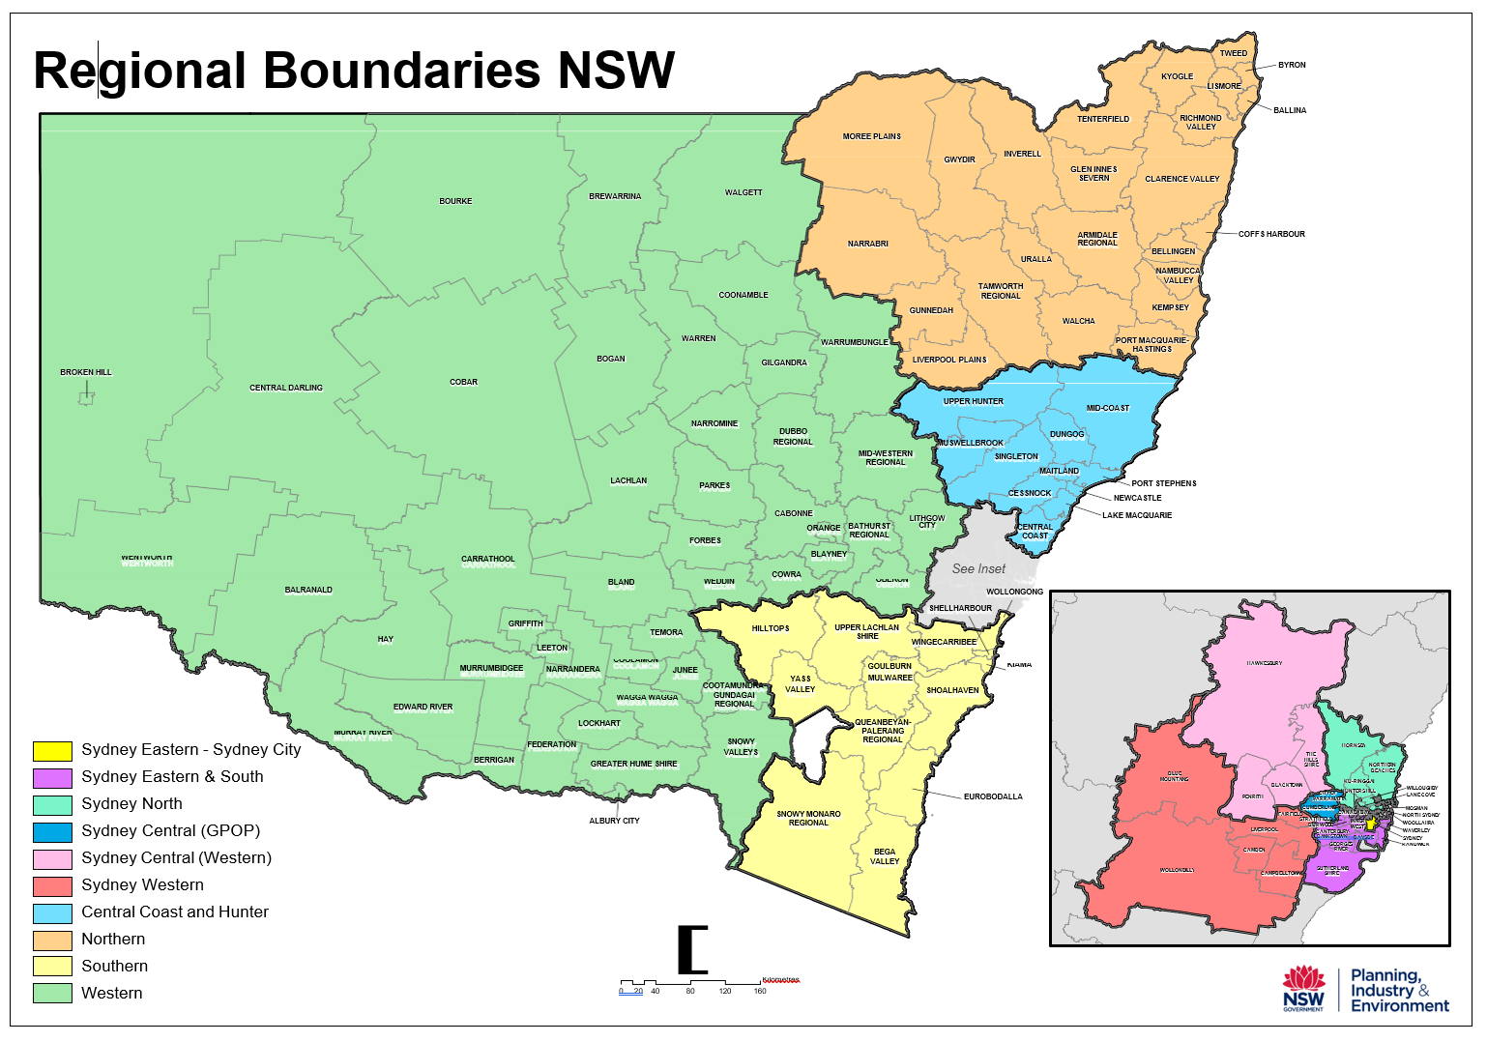
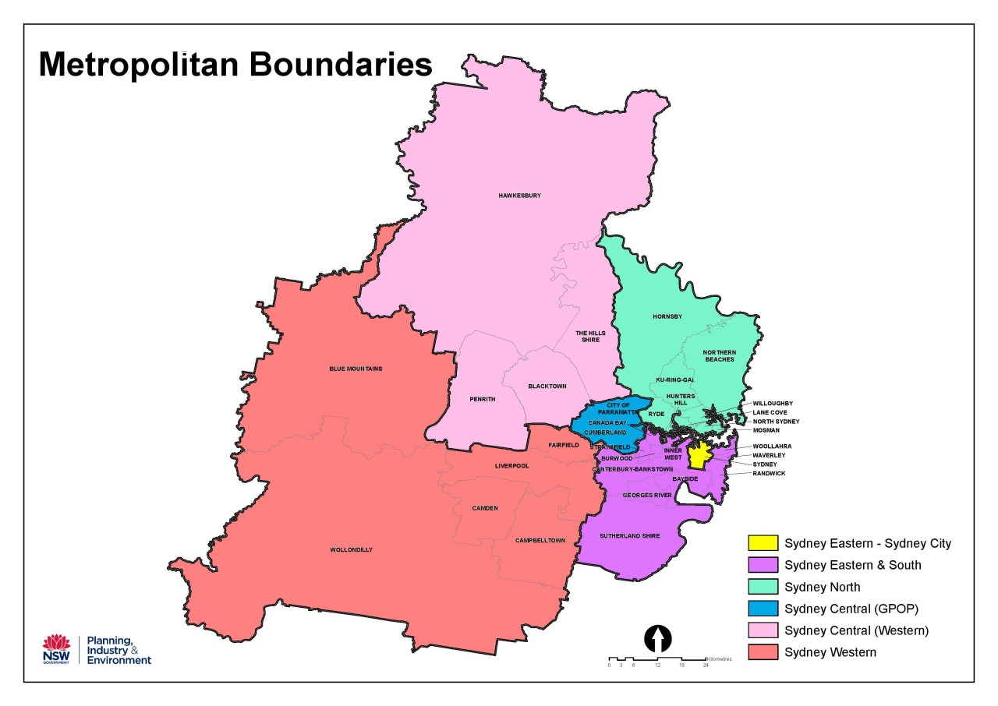
The Cabinet Office

52 Martin Place
Sydney NSW 2000

GPO Box 5341
Sydney NSW 2001

Office hours:
Monday to Friday
9.00am – 5.00pm

E: WNSWGrants@tco.nsw.gov.au
W: https://www.nsw.gov.au/women-nsw

