The Cabinet Office

Return to Work Pathways Program Guidelines
  - 2024-25 Guidelines
October 2024

Acknowledgement of Country
The Cabinet Office acknowledges the Traditional Custodians of the lands where we work and live. We celebrate the diversity of Aboriginal peoples and their ongoing cultures and connections to the lands and waters of NSW.
We pay our respects to Elders past, present and emerging and acknowledge the Aboriginal and Torres Strait Islander people that contributed to the development of this Guidelines for Return to Work Pathways Program.
We advise this resource may contain images, or names of deceased persons in photographs or historical content.

Return to Work Pathways Program Guidelines
Published by Women NSW, The Cabinet Office.
First published: October 2024

Copyright and disclaimer
© State of New South Wales through The Cabinet Office 2024. Information contained in this publication is based on knowledge and understanding at the time of writing, October 2024, and is subject to change. For more information, please visit https://www.nsw.gov.au/nsw-government/copyright.

Grant Program Details
EOI Application opening | 10:00 AEDT on 11 November 2024
EOI Application closing | 15:00 AEDT on 6 December 2024
Anticipated EOI outcome | Week commencing 13 January 2025
Full Grant Application opening | 10:00 AEDT on 20 January 2025
Full Grant Application closing | 15:00 AEDT on 14 February 2025
Application outcomes advised | April 2025
Anticipated date for Funding Deed execution (with successful applicants | April 2025
Project delivery timeframe (for successful applicants) | July 2025 – 30 June 2027
Decision-maker | Minister for Women
NSW Government Agency | Women NSW, The Cabinet Office
Type of grant opportunity | Open, competitive
Grant value (total available funding for the grant and the available individual grant amounts, excluding GST) | Total funding budget of $2 million.  Individual grant amounts from $100,000 to $250,000 (excluding GST) per applicant.
Enquiries and support | If you have any questions about the grant that are not covered in these funding guidelines, please contact Women NSW:  Email: WNSWGrants@tco.nsw.gov.au  For queries about the online grant management system, Smarty Grants, please contact the support team at:  Email: service@smartygrants.com.au  Phone: (03) 9320 6888  Available to help Monday to Friday 9:00am to 5:00 (Australian Eastern Standard time).

Contents
1 Overview of grants 6
1.1 Purpose and objectives 6
1.2 Grant value 6
1.3 Priority cohorts 6
1.4 Projects 7
1.5 Intended outcomes 7
2 Selection Criteria 8
2.1 Eligibility criteria 8
2.1.1 Requirements for Aboriginal / Torres Strait Islander Community-Controlled Organisations 8
2.1.2 Requirements for not-for-profits 9
2.1.3 Requirements for social enterprises 9
2.2 Ineligible Applicants 9
2.3 NSW National NSW National Redress Scheme sanctions 10
2.4 Eligible and ineligible uses of funding 10
2.4.1 Items eligible for grant expenditure: 10
2.4.2 Items not eligible for grant expenditure: 10
2.5 Assessment criteria 11
2.5.1 Expression of Interest assessment criteria 11
2.5.2 Application Assessment criteria 12
2.6 Evidence requirements 13
2.7 Project evaluation 13
3 Expression of Interest and Application Process 14
3.1 How to apply 14
3.1.1 Stage One - Expression of Interest Application 14
3.1.2 Stage Two – Full Grant Application 14
3.1.3 Support for Applicants 15
4 Assessment process 16
4.1 Assessment of grant applications 16
4.1.1 Stage One – Expression of Interest Application 16
4.1.2 Stage Two – Full Grant Application Assessment 16
4.1.3 Stage Three – Assessment Panel recommendations 16
4.2 Notification of application outcome 16
4.3 Feedback on applications 16
4.4 Publication of grants information 17
5 Successful grant applications 18
5.1 Variations to the approved funding activity 18
5.2 Unspent funds 18
5.3 Advertising and promotion 18
5.4 Reporting and acquittal requirements 19
5.5 Insurance 19
6 Additional information and resources 19
6.1 Disclaimer 20
6.2 Complaint handling 20
6.3 Access to information 20
6.4 Conflict of interest management 20
6.5 Confidentiality 21
7 Appendix 22
7.1 Appendix A - RTWPP Project Logic 22
7.2 Appendix B - Sources of evidence 22
7.3 Appendix C - Guidance on preparing an application and evaluation 22
7.4 Appendix D – NSW Regions 23

Overview of grants
Despite progress made over the last 50 years to improve outcomes for women, there are still ongoing barriers that limit women’s opportunities throughout their lifetimes. While diverse cohorts of women have a range of strengths to make valuable contributions to their families, communities, and workplaces, many women experience additional barriers to economic participation.
The Return to Work Pathways Program (RTWPP) was established by the NSW Government in 2023 to support women from focus communities gain increased work readiness and to secure sustainable employment. The RTWPP delivers on NSW Government priorities including the NSW Women's Strategy 2023 - 2026.
Women NSW will seek an Expression of Interest (EOI) from organisations seeking to deliver RTWPP projects. Organisations can submit one EOI only. The EOI form will be simpler and shorter to complete than an application form.
A shortlist of organisations outlining RTWPP projects that clearly demonstrate how the proposed project will deliver outcomes for women from priority cohorts and value for money will then be invited to complete the more detailed full grant application form through SmartyGrants.
Women NSW encourages applicants to read all the details in these guidelines before applying. Women NSW have a responsibility to make sure projects provide value for money. It is important you are able to demonstrate how your proposed project provides outcomes and how the grant will deliver value for money.

Purpose and objectives
The primary objective of the RTWPP is to support women from focus communities, who are experiencing complex and persistent barriers to employment, to enter or re-enter the workforce.
A variety of bespoke and tailored projects will be funded, to provide wraparound supports including training, mentoring and pathways to employment. Projects will be targeted to the nominated focus communities, responding to their specific needs, life stages and circumstances.
Projects must be targeted to supporting women into paid employment. Supporting women to achieve self-employment and/or entrepreneurship are outside the scope of the RTWPP.

Grant value
The total budget allocation for the 2024-25 RTWPP grants is $2 million. RTWPP grants are for one-off funding only, for grants between $100,000 to $250,000 each.
A minimum of 10% financial co-contribution is required. This can be cash or in-kind sources.
Only one application for funding will be accepted per organisation.

Priority cohorts
The target group for the RTWPP grants is women who face enduring and complex barriers to enter or re-enter the workforce. The 2024-25 RTWPP grants are specifically targeting eight priority cohorts of women experiencing low workforce participation and / or high unemployment rates, combined with complex intersectional barriers to employment. Applications for the 2024-25 RTWPP grants must target and demonstrate outcomes for one of the following cohorts of women:
- Aboriginal and Torres Strait Islander women
- women with disability
- carers
- young women (17-24 years)
- older women (55 years and over)
- women from culturally and linguistically diverse communities
- women living in regional, rural, and remote areas (particularly Far West NSW and North Western NSW)
- women living in Western Sydney
Consideration is made based on a distribution of projects across priority cohorts and geographic spread. Regional, rural, remote and cross border areas of NSW refers to NSW local government areas (LGAs) located outside the metropolitan areas of Greater Sydney, Newcastle and Wollongong – see the regional and metropolitan boundaries maps at Appendix D.

Projects
The RTWPP program will fund a variety of models and funding will vary according to the proposed model and corresponding extent of services to be provided, in response to priority cohorts’ needs.
Projects should provide a model delivering some or all the following components. A minimum of four service components is required. Supports can include, but are not limited to the following:
Key components | Examples of supports / services
Tailored wrap around supports | Supported referrals to services, career coaching and guidance, other activities and programs to build confidence. Time-limited support following participant’s employment.
Mentoring | Provide mentoring using a suitable mentoring model, this may include peer and volunteer mentoring.
Training | Provide appropriate training programs in a variety of formats responding to participants needs. Supported referral to other training and education options as required.
Work readiness | Pre-employment training, work readiness skills training and coaching to build participant’s capability and confidence.
Pathways to employment | Facilitated employment opportunities using models such as work experience, job placement, paid traineeships and other programs that offer established pipelines to employment.
Engagement of employers | Partnering with employers to facilitate employment options for participants and for employers to create supportive environments.

Intended outcomes
RTWPP outcomes are detailed in the RTWPP Project Logic template at Appendix A. Outcomes for participants will include:
- Entry or re-entry into the workforce within six months of participating in the program
- Sustained employment, after 12 months of participating in the program
- Increased skills to enter the workforce
- Improved levels of work readiness and confidence
- Improved mental health and wellbeing because of job security; reduced financial stress.

Selection Criteria
Selection criteria for a grant comprises both eligibility and assessment criteria. This section includes details of both eligibility and assessment criteria. EOIs are required to meet all the eligibility criteria and competitively address the EOI assessment criteria.

Eligibility criteria
Applicants are required to meet all the eligibility criteria below:
- Applicants must be a legally constituted Australian-based entity from one of these four categories:
- Aboriginal and / or Torres Strait Islander Community Controlled Organisations (ACCO).
- Incorporated, not-for-profit organisations, including community organisations.
- Social enterprises
- NSW Local councils and shires (who must be listed on the Office of Local Government), including regional organisations of councils and consortia of councils.
- Applicants must be willing to obtain appropriate public liability insurance (minimum of $10 million) if successful.
- Applications must provide a budget outlining proposed funding of eligible expenditure items (per section 2.4.1 of the Guidelines) and excluding ineligible uses of funding (per section 2.4.2 of the Guidelines). A minimum of 10 per cent funding from other sources (monetary or in-kind) must be included.
- An application must be made by a single organisation that will accept responsibility for the delivery of the project if the application is successful.
- Applicants must be based within NSW, unless they can demonstrate that the project will be run in and for the benefit of women and/or girls in NSW and that the organisation meets all regulatory, business requirements.
- Projects must be targeted to supporting women into paid employment. Supporting women to achieve self-employment and/or entrepreneurship are outside the scope of the RTWPP.
- Projects must be delivered in the period between July 2025 – 30 June 2027.
- Applicants must apply for funding within the specified amounts of $100,000 to $250,000.

Requirements for Aboriginal / Torres Strait Islander Community-Controlled Organisations
For the purpose of this grant, an eligible Aboriginal and / or Torres Strait Islander Community Controlled Organisation builds the strength and empowerment of Aboriginal and Torres Strait Islander communities and people, and is:
- Incorporated under relevant legislation.
- Not-for-profit (see further requirements below).
- Controlled and operated by Aboriginal and / or Torres Strait Islander people.
- Connected to the community or communities in which they deliver services.
- Governed by a majority Aboriginal and / or Torres Strait Islander governing body.
Applicants will be required to provide documentation to support their ACCO status such as:
- an Office of the Registrar of Indigenous Corporations certificate of registration.
- a constitution/rule book which shows the organisation requirements.
- letters or surveys from other local Aboriginal organisations, groups or relevant community stakeholders or outcomes from community feedback.

Requirements for not-for-profits
Eligible not-for-profit organisations must be registered and approved as a not-for-profit body with a current and up-to-date record in at least one of the following categories:
- Charities, trusts, and cooperatives that are registered with the Australian Charities and Not-for-profits Commission (ACNC).
- Organisations with Deductible Gift Recipient (DGR) status.
- Organisations with Public Benevolent Institution status.
- Associations (registered under the Associations Incorporation Act 2009 and with NSW Fair Trading).
- A Local Aboriginal Land Council under the Aboriginal Land Rights Act 1983 (NSW) and registered with the NSW Aboriginal Land Council.
- Indigenous Corporations registered with the Office of the Registrar of Indigenous Corporations.

Requirements for social enterprises
To be considered a social enterprise, an organisation must satisfy each of the criteria below:
- be established with a social, cultural or environmental purpose consistent with a public and/or community benefit.
- trade commercially to fulfil their purpose.
- derive a substantial portion of their income from trading commercially.
- reinvest the majority of their surplus in the fulfilment of their purpose.
Social Traders certification or People and Planet First global verification is required as evidence to demonstrate the social enterprise definition is met. Organisations will be required to indicate which certification or verification they will use at the EOI stage and provide the required evidence at the full application stage.

Ineligible Applicants
Funding will not be provided to:
- Individuals or groups of individuals, including sole traders.
- Unincorporated organisations.
- For profit commercial organisations and entities.
- Sub-contractors – either for program management or for project delivery on behalf of non-eligible organisations.
- NSW Government or Australian Government agencies or their entities (including public trusts).
- Applicants requesting 100 percent project funding from Women NSW.
- Projects which already receive NSW or Commonwealth Government funding.
- Applicants with outstanding acquittal requirements with Women NSW.
- Applicants with an obligation under the NSW National Redress Scheme who have not joined the Scheme (further information outlined in section 2.3 of the Guidelines).

Note: NSW Government schools, Local Health Districts and public hospitals are ineligible to apply, however, an associated incorporated not-for-profit body, such as a Parents and Citizens Association or hospital auxiliary will be eligible to apply for funding.

NSW National NSW National Redress Scheme sanctions
The NSW Government will not award a Grant Funding Arrangement to a non-government organisation with Redress Obligation (or to any of its Related Entities) if that non-government organisation:
- Has declined to join the Scheme, or
- At the expiry of six months after the time it is notified to join the Scheme, has failed to do so.
For further information visit the website NSW National Redress Scheme sanctions.

Eligible and ineligible uses of funding
Applicants will not be eligible where the budget includes ineligible items.

Items eligible for grant expenditure:
Grant funding can only be used for expenses directly related to the delivery of the project in NSW. Applicants must clearly set out proposed expenditure in the application and outline how the project will demonstrate value for money.

Items not eligible for grant expenditure:
- Business capital or start-up funding.
- Purchase of, or cost of infrastructure, assets and/or capital equipment and works.
- Permanent equipment purchases (e.g. computers, phones or iPads or other items not specific to the event).
- Operating costs of the organisation or recurrent expenses (e.g. insurance, leases, bills, general office consumables and disposables).
- Permanent wages, salaries and on-costs for ongoing staff.
- Organisational development costs for internal staff (e.g. staff training, conferences, workshops, planning days).
- Conferences – you cannot use the fund to conferences and workshops, or to pay for an individual or group attend a conference. This does not include structured, time limited training sessions and workshops with practical and clear outcomes for project participants.
- Prizes, competition or awards (e.g. cash giveaways, lucky door prizes, raffle prizes).
- Interstate and/or overseas travel allowances or costs associated with membership of boards/councils.
- Retrospective costs (any money spent before a grant is approved).
- Fundraising events that are for the purposes of fundraising for charities or for the organisation’s personal use.
- Any project run solely for commercial purposes to the benefit of the delivery partner but not the program participants.
- Projects and activities coordinated by NSW Government Departments and Statutory Authorities.
- Research projects, including those which are co-funded by State or Federal Governments and/or other organisations.
- Purchase of promotional/awareness raising merchandise that will be sold for profited on.
- Acquittal, auditing or reporting costs.
- Fees associated with an auspice agreement.
- Existing debt or loan repayments.
- Events that encourage gambling (e.g. raffles, bingo) or the consumption of alcohol.
- Non-essential costs which are not related to the proposed core activity

Assessment criteria

Expression of Interest assessment criteria
Expressions of Interest will be shortlisted against the following criteria:
Criteria | Specific information and evidence required
1. Priority cohort | Demonstrates strong connections and extensive work with the nominated priority cohort.  Organisations demonstrating their project will target and achieve outcomes for one nominated priority cohort will score more highly.
2. Effective service delivery model | Demonstrates a well-developed service delivery model that provides the appropriate types and levels of supports, which address the barriers experienced by women in the nominated priority cohort and will result in employment outcomes for the women participating.  Organisations clearly demonstrating a service delivery model that is tailored to the needs and outcomes for one nominated priority cohort will score more highly.  RTWPP priority cohorts, key project components and intended outcomes are set out in sections 1.3, 1.4 and 1.5 respectively.
3. Organisational capacity | Demonstrates extensive experience in delivering employment support programs, established partnerships within the employment sector and / or employers, and capacity to deliver the project in line with the RTWPP objectives and outcomes.  Organisations demonstrating requisite skills, experience and capacity in delivering employment support programs for one priority cohort will score more highly.
- Value for money | Provides a clear rationale for the service delivery model and how it achieves value for money, including the minimum number of participants that will be supported.  Organisations demonstrating a clear rationale for the service delivery model and its associated costs will score more highly.
Due to the competitive nature of the RTWPP grants, not all EOIs that meet the assessment criteria will be shortlisted.

Application Assessment criteria
Shortlisted organisations invited to apply for a RTWPP grant must competitively meet the following assessment criteria, of equal weighting, to be considered for funding:
Criteria | Specific information and evidence required
1. Effective service delivery model | - The project has a well-developed service delivery model that sets out the types, level, and intensity of supports to be provided to participants and are tailored to the needs of the women in the one nominated priority cohort.  - The application provides a rationale and costings for the model. The application must outline the minimum number of participants and how the proposed service model represents value for money. In recognition of women with complex needs, higher cost models for women with complex needs will be considered but should be clearly outlined and costed, including evidence that supports the model.  - There is a clear project plan for delivering the project which sets outs key project activities and milestones.  RTWPP priority cohorts and key project components are set out in sections 1.3 and 1.4.
2.Partnerships and engagement | - The application outlines the partnerships and community engagement required to support the project, and clearly outlines partner contributions.  - The application demonstrates effective referral pathways with relevant services and community organisations.  - The application demonstrates partnerships with employers and businesses to support employment pathways.
3.Organisational capacity | - Applicants must demonstrate that their organisation has the appropriate skills and expertise to deliver the project, including prior experience delivering employment support programs and their outcomes.  - Projects must also demonstrate capacity to provide ongoing value beyond the funding provided under the RTWPP grants.
4. Outcomes | - The application sets out clearly defined outcomes and how they will be measured and evaluated.  - The application includes an evaluation strategy with metrics for measuring success in achieving outcomes.  RTWPP outcomes are set out in section 1.5 and the attached RTWPP Project Logic.
5. Value for money | - Costs are clearly outlined in the budget including:  - expenditure items are detailed and clearly link to activities and outcomes  - funding sought from Women NSW  - in-kind contributions  - Projects must represent value for money in terms of both overall costs, and the value of the outcomes and benefits that will be delivered.
6. Evidence based | - The application has a clear and well-refined problem statement, that outlines how the project will respond to the needs of women from the priority cohort experiencing complex barriers to employment. The project approach and service delivery model are supported by evidence and / or leading practice.

Evidence requirements
Projects must be evidence-based. Applicants must be able to demonstrate the evidence defining the problem, that the proposed model is fit for purpose, will effectively addresses barriers to economic advancement for the priority cohort, and will achieve program outcomes.
The evidence for both the problem and intervention should be:
- Relevant: the evidence is directly related to the problem and intervention.
- Reliable: the evidence is from a source or person that has knowledge and/or experience related to the problem and intervention. The reliability of evidence is strengthened when it can be supported through different information-gathering methods.
- Current: the evidence is up to date (to provide a baseline against which change can be measured).
- Adequate: there is enough evidence to verify the existence and size of the problem, as well as the rigour and effectiveness of the intervention.
The specific problem should be articulated in terms of extent, demographics, and location.
Evidence of the problem can be demonstrated through:
- published data
- peer-reviewed published research, and/or
- independent program evaluations.
It is recognised that some innovative solutions may lack a strong evidence base, however, applicants should demonstrate and apply relevant experience, practice wisdom, and correlations with evidence from other areas.
Appendix B contains a non-exhaustive list of sources of evidence.

Project evaluation
- You must include in your application how you will evaluate your project. The evaluation should include a process and outcome evaluation at a minimum.
- A process evaluation looks at how a project works and whether the project activities have been implemented as intended. An outcome evaluation seeks to evaluate the extent to which a project meets its goals or objectives.
A Project and Evaluation Plan will be required to be submitted as the first deliverable for the project. Appendix C provides some guidance for preparing applications and evaluation.

Expression of Interest and Application Process
To streamline the application process, this year Women NSW will use a two-stage process for Pathways Program grants.
The first stage involves completing a short Expression of Interest (EOI) form through SmartyGrants. Applicants will not be able to apply for a grant without submitting an Expression of Interest.
Women NSW will select a shortlist of organisations based on the EOI Assessment criteria and invite shortlisted organisations to complete a full grant application form in the second stage of the process.
Full grant applications will go through a comprehensive assessment process to determine the successful projects.
Frequently Asked Questions (FAQs) to assist applicants with the Expression of Interest and Full Grant application processes will be available on the 2024-25 RTWPP grants website.

How to apply

Stage One - Expression of Interest Application
Eligible organisations can submit only one EOI through SmartyGrants from 11 November to 6 December 2024. You will receive an automated email via SmartyGrants when Women NSW receives your EOI.
If an organisation submits multiple EOIs, only the first submitted EOI will be assessed, and all others will be deemed ineligible.
Your EOI will require you to provide a project overview and address the selection criteria as set out at section 2.5.1.
A submitted EOI in written form, can be reopened upon request until 6 December 2024. To reopen an EOI, email wnswgrants@tco.nsw.gov.au.
We recommend applicants submit forms in SmartyGrants at least two hours prior to the deadline to ensure any required documents upload properly. Late EOI applications will not be accepted.
Stage One – EOI applications will be assessed by Women NSW for eligibility and then scored against the assessment criteria. Shortlisted organisations will be invited to submit a full grant application for a 2024-25 RTWPP grant.
Applicants must not provide false or misleading information, and any false or misleading information will render the EOI ineligible.

Stage Two – Full Grant Application
Organisations invited to apply must complete an application form through SmartyGrants between 10am on 20 January 2025 to 3pm on 14 February 2025.
We recommend applicants submit forms in SmartyGrants at least two hours prior to the deadline in order to ensure any required documents upload properly. Late Full grant applications will not be accepted.
Applications are completed and submitted online via the SmartyGrants Management portal. You will receive an automated email via SmartyGrants when Women NSW receives your application.
Submission of an application does not guarantee funding.
If successful, the Funding Agreement and final acquittal for the grant will be managed using the SmartyGrants portal and AdobeSign.
Applicants must not provide false or misleading information, and any false or misleading information will render the application ineligible.

Support for Applicants

Accessibility
To support greater accessibility applicants may request to submit a video response to the Full Grant application questions. Women NSW staff are available to support applicants with recording and preparing a file for upload, if required.

Support
For questions or support to applicants or to reopen an application, email wnswgrants@tco.nsw.gov.au. A submitted application can be reopened upon request until applications close.
For technical issues related to the SmartyGrants platform please contact the support team at:
Email: service@smartygrants.com.au
Phone: (03) 9320 6888
Available to help Monday to Friday 9:00am to 5:00pm (AEDT)

SmartyFile
Applicants have the option to create a SmartyFile profile for your organisation. SmartyFile allows organisations to collaborate with team members, pre-fill information into forms and manage, view, search, and sort submissions across multiple funders in one spot. To learn more, go to About SmartyFile

Assessment process

Assessment of grant applications
This is an open and competitive grants program. Applicants will be assessed and scored against the criteria. Applications with the highest scores are more likely to be funded.
Please note that there can be no assumed knowledge. The assessment panel can only consider the information provided in your application.
All applications are assessed through the staged process as outlined below:

Stage One – Expression of Interest Application
EOIs are initially reviewed by Women NSW staff to ensure compliance with mandatory eligibility criteria and alignment with the priority cohorts.
Any EOI deemed ineligible will not proceed to the next stage of the assessment.
EOIs will then be shortlisted according to the assessment criteria in section 2.5.1 of the Guidelines.
Due to the competitive nature of the RTWPP grants, not all EOIs that meet the assessment criteria will be shortlisted.
Recommendations of the top ranking EOIs will be approved by the Director, Women NSW.
All EOI applicants will be advised of their application outcome in writing through the SmartyGrants portal. The top ranking EOIs will be invited to submit a full grant application.

Stage Two – Full Grant Application Assessment
All submitted full grant applications will be assessed individually by members of the Assessment Panel against the assessment criteria in section 2.5.2 of the Guidelines and given a score. Applications will then be ranked according to the total scores.
The panel will consist of qualified and experienced representatives and will include Women NSW and other relevant NSW Government representatives and an independent panel member who identifies as Aboriginal and/or Torres Strait Islander.

Stage Three – Assessment Panel recommendations
The assessment panel will meet and discuss all full grant applications. The assessment panel will then make their recommendations to the final decision maker, the Minister for Women for approval.
Applicants will be notified in writing of the outcome of the assessment process.

Notification of application outcome
All full grant applicants will be advised of their application outcome in writing through the SmartyGrants portal prior to any public announcement.
Notification will also make clear how and when grants will be announced publicly.
There is no appeals process available for this grant program.
Announcements will not be made regarding grants awarded before the grantee has been informed.

Feedback on applications
Funding is limited and not all applications are successful. Feedback will not be provided for unsuccessful Expression of Interest applications.
Unsuccessful full grant applicants can request tailored feedback on their application delivered by the Women NSW team. You will be provided with the option to request feedback for up to two months after your unsuccessful notification.

Publication of grants information
The NSW Grants Administration Guide requires that certain information is published in relation to grants awarded no later than 45 calendar days after the grant agreement takes effect (see section 6.5 of the Guide and Appendix A to the Guide). This information is also open access information under the Government Information (Public Access) Act 2009 (NSW) (GIPA Act), which must be made publicly available unless there is an overriding public interest against disclosure of the information.
In accordance with these requirements, relevant information about the grants awarded will be made available on the NSW Government Grants and Funding Finder as soon as possible after the grant funding is approved or declined.
All records in relation to this decision will be managed in accordance with the requirements of the State Records Act 1998 (NSW).

Successful grant applications
Grant recipients are required to enter into a funding agreement with The Cabinet Office. Organisations funded by The Cabinet Office must operate in accordance with their funding agreement and with legislation, policies, and guidelines relevant to their project funding.
Successful grantees are required to sign and return their funding agreement within two weeks of receipt. Funding agreements can only be signed by authorised officers of your organisation. An authorised officer may be a member of the executive/committee as deemed under the Articles of Association or Constitution for a not-for-profit organisation.
All applicants must provide the contact details (email address, phone number, name, and position) of the relevant authorised signatories, or their delegates, in the application form.
Incorporated Associations will be required to provide a copy of the resolution or delegation confirming that the signatories have the authority to execute a Deed or Contract on behalf of the Association.
Australian Public Companies will be required to provide evidence confirming your corporate legal structure by way of a paid ASIC extract. ASIC Company Extracts can be purchased online using a credit card on the ASIC website at a cost of $10.
It is the applicant’s responsibility to ensure staff availability to complete and sign documents, to carefully read the terms and conditions of their funding agreement, and for it to be signed by the correct authorised signatories.
Important terms and conditions associated with the funding are attached to the funding agreement.
As part of the funding agreement an invoice template is provided. Once the funding agreement has been executed by all relevant parties and the correct invoice received, the grant funds will be paid to the nominated bank account and a copy of the executed document will be emailed.
Grant recipients should not make public announcements about their project without prior approval from Women NSW. Once you have been notified that the grant is no longer under embargo, you can communicate the grant.

Variations to the approved funding activity
Any variations to the proposal for which a grant has been awarded, including project scope or activities, location or timeframes outlined in the application form and grant program guidelines, must be submitted in writing for approval from Women NSW. Unapproved variations may result in the withdrawal of the grant offer or termination of the funding agreement. Approved variations may require amendment to the funding agreement, if the agreement has already been executed.

Unspent funds
Organisations must not use the money provided for the project, nor any interest earned on the money, for any other purpose beyond what is specified in the approved submitted application.
Organisations must not carry over funds provided for the approved project, to other programs, events, or organisational operating budgets. All grant monies are required to be spent on the approved project or the funds must be returned.

Advertising and promotion
Successful grant recipients are responsible for the promotion and advertising of their project.
Grant recipients must use the official NSW Government branding on all promotional and advertising materials relating to their grant-funded activities.
Grant recipients agree to information about the project being used for evaluation, promotional and media purposes. Should your application be successful, The Cabinet Office (Women NSW) may need to provide certain information to the media and Members of Parliament for promotional activities.
Grant recipients agree to obtain consent from participants for still and moving images of participants captured by project staff and provided to The Cabinet Office. Appropriate consent documentation will be provided to successful grant recipients.
Grant recipients acknowledge that the information provided in the application, and any images of the project provided to The Cabinet Office, may be used in media and promotional activities such as publishing case studies, social media, and website content, and/or media releases.
Successful applicants are required to acknowledge the financial support by the NSW Government.
The Cabinet Office may also publish overarching information about grants awarded including the name of the grant, a description of the grant, the number of grant recipients, the total value of the grant opportunity and the decision-maker.

Reporting and acquittal requirements
A quarterly written report on progress, including progress against RTWPP Key Project Indicators, will be required, to support the monitoring of project delivery.
All reporting will be submitted online through SmartyGrants by the dates specified in the funding agreement.
All projects must be delivered, and funds must be expended, by 30 June 2027. Grant recipients must provide Women NSW with a Final Completion Report and Acquittal Statement; Women NSW will send you the form prior to the required date for you to complete and submit it online through SmartyGrants by the date specified in their funding agreement. If an acquittal is not received by the due date, Women NSW may deem the project activities not to have taken place and may request that any funding that has been provided is repaid within 28 days.
It is a requirement that all financial records related to grant expenditure and acquittal be retained by the organisation for seven years. If the committee changes, these documents must be forwarded to the new incoming committee.

Insurance
All grant-funded events and activities must be covered by Public Liability Insurance.
If your organisation is not covered, you will need to approach another organisation to sponsor your application so that your event will be covered under their Public Liability Insurance (such as your local council).
Your organisation is required to provide a valid Certificate of Currency for Public Liability Insurance with a minimum cover of $10 million in the name of the applicant before funding can be released.
In all sponsored grant applications, Women NSW’s primary relationship is with the sponsoring body, as they are responsible for the management of the grant.

Additional information and resources

Disclaimer
Submission of an application does not guarantee funding. Previously successful applicants are not guaranteed funding.
Women NSW accepts no responsibility for the event, irrespective of the funding provided by the agency to support the project, and irrespective of its listing on the NSW Women’s website or other Women NSW publications.
Organisations are responsible for meeting their duty of care and all other obligations to project participants, volunteers, and other stakeholders. Organisations should give due consideration to the safety of any children, young people or other vulnerable people involved in their project.
The Office of the Children’s Guardian can provide advice on child safety. Organisations who do not usually work with children or young people should consider partnering with an organisation or other stakeholder who does have expertise in child safety.

Complaint handling
Any concerns about the grant should be submitted in writing to The Cabinet Office.
The Cabinet Office is committed to responding to external complaints fairly, efficiently, and effectively. Concerns and complaints procedures follow the processes set out in the Cabinet Office external complaints handling policy available at Complaints policy.

Access to information
The NSW Grants Administration Guide requires that certain information is published in relation to grants awarded no later than 45 calendar days after the grant agreement takes effect (see section 6.5 of the Guide and Appendix A to the Guide). This information is also open access information under the Government Information (Public Access) Act 2009 (NSW) (GIPA Act), which must be made publicly available unless there is an overriding public interest against disclosure of the information.
In accordance with these requirements, relevant information about the grants awarded will be made available on the NSW Government Grants and Funding Finder as soon as possible after the grant funding is approved or declined. Information received in applications and in respect of applications is treated as confidential. All funding decisions and assessment outcomes are to be kept confidential until announces and applicants notified. However, documents in the possession of the Government are subject to the provisions of the Government Information (Public Access) Act 2009. Under some circumstances a copy of the application form and other material supplied by the applicant may be released, subject to the deletion of exempt material, in response to a request made in accordance with the Act.
Note that documents submitted as part of a grant application may be subject to an application under the GIPA Act or an order for papers under Standing Order 52.

Conflict of interest management
Any real or perceived conflicts of interest that may arise during the assessment process are effectively managed and disclosed. Risks are managed in accordance with The Cabinet Office systems for risk management. Risk is also mitigated through the guidelines. Fraud controls are in place around conflicts of interest management. Any conflicts of interest are required to be declared and managed in accordance with the Cabinet Office Code of Conduct. Risk management will occur throughout the grant life cycle.

Confidentiality
Successful applicants may be required to keep the outcome of the application process confidential until the Government makes a public announcement.
Women NSW follows all requirements of confidentiality required as part of the grants administration and assessment process as outlined in the NSW Grants Administration Guide.

Appendix

Appendix A - RTWPP Project Logic
The RTWPP Project logic is a structured framework that outlines the relationship between a project's objectives, input, activities, outputs, outcomes, impacts and benefits, helping to ensure clarity and coherence in planning and execution. It illustrates how resources are used to achieve desired results and identifies key assumptions and risks.

Appendix B - Sources of evidence
Below is a non-exhaustive list of resources which can be used as a starting point to gather evidence for specific problem (i.e. the need for the intervention), as well as the evidence that the specific intervention (your project proposal) is fit for purpose and will address the identified problem.
Australian Bureau of Statistics (ABS) Gender Indicators, Australia
Australian Institute of Family Studies (AIFS)
NSW Gender Equality Budget Statement 2023-24
NSW Gender Equality Dashboard

Appendix C - Guidance on preparing an application and evaluation
Below is a non-exhaustive list of sources of guidance and information to assist in developing projects for the 2024-25 RTWPP funding program and preparing applications.
Office for Social Impact Investment Technical Guide: Outcomes Measurement for social impact investment proposals to the NSW Government
The Technical Guide was created to support social impact investment proposals, however, it includes guidance relevant for applications under the RTW PP funding program.
At a minimum, applicants should read:
Section 2.2.1 Identifying the target population
Section 2.2.2 Expected effect of the intervention
Section 2.3.1 Defining program logic
Section 2.3.2 Key principles of program logic
Section 2.4 Outcomes

Project evaluation
Applicants should refer to the below guidance when preparing their application:

Premier’s Department Evaluation Toolkit
The Evaluation Toolkit provides advice and resources for planning and conducting a program evaluation.

NSW Government Program Evaluation Guidelines
The Program Evaluation Guidelines outline best practice principles to plan and conduct program evaluations.

Appendix D – NSW Regions
Regional, rural, remote and cross border areas of NSW refers to the NSW local government areas (LGAs) located outside the metropolitan areas of Greater Sydney, Newcastle and Wollongong – as illustrated in the Regional and Metropolitan boundaries maps below.
For further clarity please read our Frequently Asked Questions.
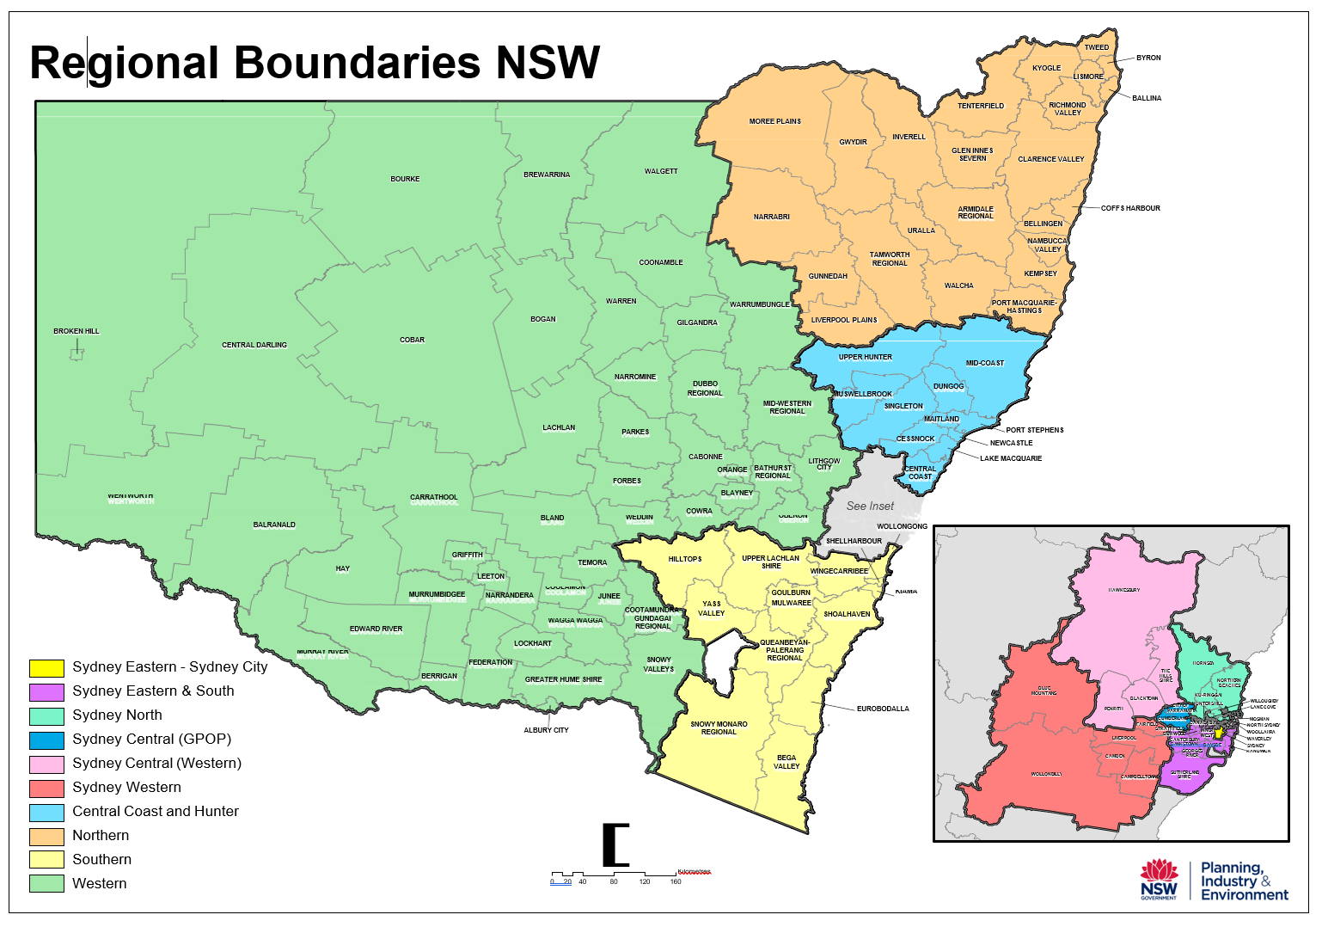
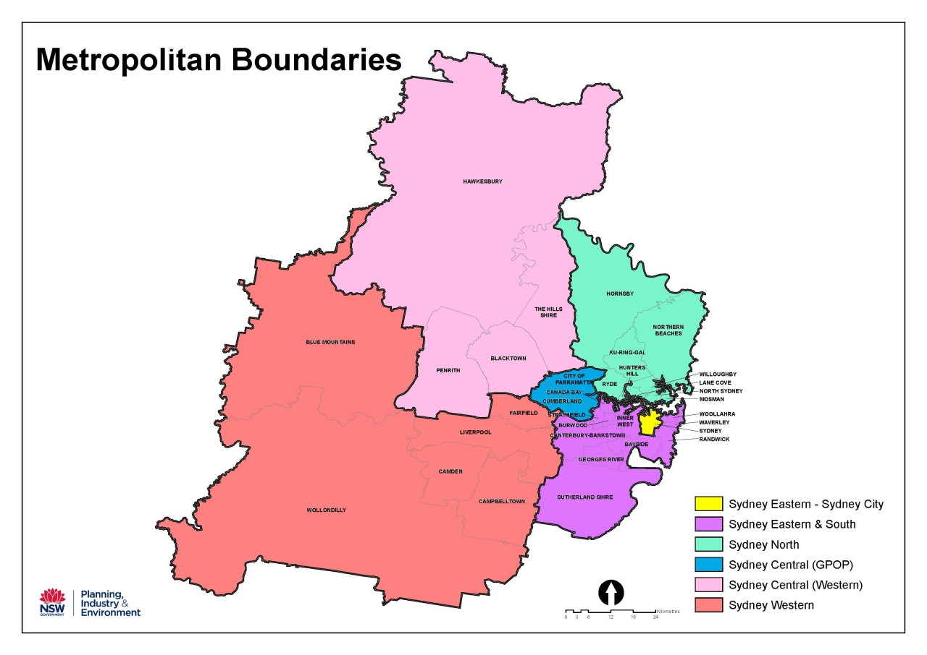

The Cabinet Office

52 Martin Place
Sydney NSW 2000

GPO Box 5341
Sydney NSW 2001

Office hours:
Monday to Friday
9.00am – 5.00pm

E: WNSWGrants@tco.nsw.gov.au
W: https://www.nsw.gov.au/women-nsw

