The Cabinet Office

Investing in Women Grants
  - 2025-26 Guidelines
August 2025

Acknowledgement of Country
The Cabinet Office acknowledges the Traditional Custodians of the lands where we work and live. We celebrate the diversity of Aboriginal peoples and their ongoing cultures and connections to the lands and waters of NSW.
We pay our respects to Elders past, present and emerging and acknowledge the Aboriginal and Torres Strait Islander people that contributed to the development of these guidelines for the Investing in Women grants.

Investing in Women Grants
Published by Women NSW, The Cabinet Office
First published: August 2025

Copyright and disclaimer
© State of New South Wales through The Cabinet Office 2025. Information contained in this publication is based on knowledge and understanding at the time of writing, August 2025, and is subject to change. For more information, please visit https://www.nsw.gov.au/nsw-government/copyright.

Grant Round Details
Applications open | 10:00 AEDT on 15 September 2025
Applications close | 15:00 AEDT on 3 October 2025
Application outcomes advised | November 2025
Anticipated date for Funding Deed execution (with successful applicants ) | November 2025
Project delivery timeframe (for successful applicants) | 1 January 2026 to no later than 31 December 2027
Decision-maker | Deputy Secretary, Social Policy and Intergovernmental Relations, The Cabinet Office
NSW Government Agency | Women NSW, The Cabinet Office
Type of grant opportunity | Targeted, competitive
Grant value (total available funding for the grant and the available individual grant amounts, excluding GST) | Total funding budget of $445,701  Applicants can request: $50,000 - $250,000
Enquiries | If you have any questions about the grant that are not covered in these funding guidelines, please contact Women NSW:  Email: WNSWGrants@tco.nsw.gov.au  For queries about the online grant management system, Smarty Grants, please contact the support team at:  Email: service@smartygrants.com.au  Phone: (03) 9320 6888  Available to help Monday to Friday 9:00am to 5:00 (Australian Eastern Standard time).
NB: The above dates are proposed only and are subject to change. The Cabinet Office (Women NSW) will notify applicants of any changes to timeframes and deadlines.

Contents
1 Overview of the grants 1
1.1 Purpose 1
1.1.1 Economic opportunity and advancement 1
1.1.2 Health and wellbeing 1
1.1.3 Participation and empowerment 1
1.2 Intended outcomes 2
1.2.1 Economic opportunity and advancement 2
1.2.2 Health and wellbeing 2
1.2.3 Participation and empowerment 2
1.3 Consideration of Pillars 2
1.4 Projects in regional, rural and remote NSW 3
1.5 Types of projects 3
1.6 Grant value 3
2 Selection criteria 4
2.1 Eligibility criteria 4
2.1.1 Who is eligible to apply 4
2.1.2 Requirements for Not for Profits: 4
2.1.3 Requirements for social enterprises 5
2.2 Ineligible Applicants 5
2.3 NSW National Redress Scheme sanctions 5
2.4 Project start and end dates 6
2.5 Eligible and ineligible uses of funding 6
2.5.1 Items eligible for grant expenditure: 6
2.5.2 Items not eligible for grant expenditure: 6
2.6 Assessment criteria 7
2.7 Evidence requirements 9
3 Application process 9
3.1 How to apply 9
3.2 Support for Applicants 10
3.2.1 Accessibility 10
3.2.2 Support 10
3.2.3 SmartyGrants 10
4 Assessment process 11
4.1 Assessment of grant applications 11
4.1.1 Stage 1 – eligibility 11
4.1.2 Stage 2 – assessment 11
4.1.3 Stage 3 – decision 11
4.2 Notification of application outcome 11
4.3 Feedback on applications 12
4.4 Publication of grants information 12
5 Successful grant applications 12
5.1 Project evaluation 13
5.2 Variations to the approved funding activity 13
5.3 Unspent funds 13
5.4 Advertising and promotion 14
5.5 Reporting and acquittal requirements 14
5.6 Insurance 14
6 Additional information and resources 14
6.1 Disclaimer 14
6.2 Complaint handling 15
6.3 Access to information 15
6.4 Conflict of interest management 15
6.5 Confidentiality 15
7 Appendix 16
Appendix A – Investing in Women Project Logic template 16
Appendix B - Sources of evidence 16
Appendix C - Project Evaluation 16
Appendix D – NSW Regions 16

Overview of the grants
Since 2013, $6.5 million has been awarded to 138 projects through the Investing in Women Program. Eleven rounds of Investing in Women funding have been delivered to enhance women’s economic opportunities, health, and leadership in NSW. More information about successful projects is available on the Women NSW website.
In response to priorities identified in the Keeping Women Out of Prison (KWOOP) Ministerial roundtable in February 2025, the 2025-26 round of Investing in Women is a targeted, competitive round open to a small number of potential grantees who are working with women and girls in contact with the criminal justice system.
Women NSW encourages applicants to read all the details in these guidelines before applying and refer to the FAQs. Women NSW has a responsibility to make sure projects provide value for money. It is important you are able to demonstrate how your proposed project provides outcomes and how the grant will deliver value for money.
The Minister for Women has approved these guidelines and the launch of this grant program. Final decisions will be made by the Deputy Secretary, Social Policy and Intergovernmental Relations (The Cabinet Office) as the Minister’s delegate.

Purpose
The purpose of the Investing in Women Funding Program is to fund innovative projects that focus on the three pillars that align with the NSW Women’s Strategy (2023 – 2026).

Economic opportunity and advancement
Projects should contribute to improving women’s economic opportunities and advancement and support diverse and flexible employment opportunities for women and girls in NSW. For example, projects that:
- Increase women’s opportunities in the workplace
- Focus on transitions between careers and life stages
- Provide pathways into work, careers, and leadership
- Support financial security, capability, and wellbeing throughout life stages, including retirement

Health and wellbeing
Projects should contribute to promoting and supporting a holistic approach to women’s health and wellbeing. For example, projects that:
- Promote safe relationships, safe communities
- Promote understanding and awareness of women’s and girls’ health needs
- Provide services and support for women’s and girls’ physical and mental health
- Secure housing, preventing homelessness

Participation and empowerment
Projects should contribute to supporting women’s engagement through social networks and access to information. For example, projects that:
- Challenge gendered norms, roles, and expectations
- Create leaders in community and work
- Uplift focus communities
- Rebuild connections and engage with community

Intended outcomes
Investing in Women grants aim to achieve the following outcomes:

Economic opportunity and advancement
- Increase in women’s labour force participation in NSW
- Increase in gender equality for taking leave to care for others in NSW
- Decrease in gender segregation in the NSW workforce
- Decrease in the gender pay gap in NSW
- Increase in women’s personal financial wellbeing in NSW
- Increased skills to enter the workforce
- Improved levels of work readiness and confidence
- Reduced financial stress
- Increase in number of women-owned/led businesses

Health and wellbeing
- Improved mental health and wellbeing
- Improved physical health
- Improved access to health services and information for [diverse] women
- Increase in actual and perceived safety for women in NSW
- Increase in women’s life satisfaction in NSW
- Increase in safe and stable housing for women in NSW

Participation and empowerment
- Decrease in gender segregation in NSW education
- Increase in completion of education and training by girls and women in NSW
- Increase of [diverse] women in senior leadership in NSW
- Increase in women’s social connectedness in NSW
- Increased participation by women in sport in NSW
- Increased participation by women in creative industries in NSW
- Increased volunteering by women in NSW
- Increased consultation and co-design with diverse women in NSW

Consideration of Pillars
As other grants currently administered by Women NSW focus on Pillar 1.2.1 Economic opportunity and advancement, priority will be given to projects targeting Pillars 2 (see 1.2.2 Health and Wellbeing) and 3 (see 1.2.3 Participation and Empowerment). However, competitive projects targeting Pillar 1 will also be considered.

Projects in regional, rural and remote NSW
Projects will be selected with the aim of ensuring a geographical spread of activities and a balance of metropolitan and regional areas.
‘Regional NSW’ refers to all of the parts of NSW that sit outside the metropolitan areas of Greater Sydney, Newcastle and Wollongong – see the Regional and Metropolitan boundaries maps at Appendix D.

Types of projects
Projects which address “Signposts for the Future” in Pillars 2 and 3 from the NSW Women’s Strategy are the types of projects likely to be granted funding. Projects which address Pillar 1 of the Strategy or other innovative programs will also be considered.
Examples include:
Pillar 2: Health and wellbeing
- Programs for women and girls in correctional and youth justice centres with a focus on trauma, women, and girls as parents, Aboriginal and Torres Strait Islander women and girls, and the transition from correctional centres to life in the community.
- Projects which improve access to early intervention, mental health, and wellbeing support for women and girls in contact with the criminal justice system.
- Projects addressing the needs of women and girls in contact with the criminal justice system who are at risk of housing insecurity and homelessness.
Pillar 3: Participation and Empowerment
- Programs that foster leadership in younger women and girls in contact with the criminal justice system and create pathways to leadership positions in public and private organisations.
- Projects which advocate for meaningful engagement with women and girls in contact with the criminal justice system across relevant areas of government, including in policy development and program design and implementation.
- Projects which build opportunities for women and girls in contact with the criminal justice system to be leaders and to promote positive representations of women in these communities.
- Projects to increase women and girls in contact with the criminal justice system’s participation in sport or encouraging them to be physically active through sport from adolescence into adulthood.

Grant value
Women NSW funds multiple Investing in Women projects, with total funding of $1 million per annum.
This targeted round will allocate the $445,701 remaining in the 2025/26 budget after funding ongoing multi-year projects in previous rounds.
In this current round, organisations can apply for funding between $50,000 and $250,000.
Funding requests will be considered competitive depending on the project model, the number of participants to be supported, and the level and intensity of services and supports provided to participants.
A minimum of 10% financial co-contribution is required per annum from cash or in-kind sources.

Selection criteria
Selection criteria for a grant comprises both eligibility and assessment criteria. Applicants are required to meet all the eligibility criteria and competitively address the assessment criteria.

Eligibility criteria

Who is eligible to apply
To be eligible, applicants must:
- be a legally constituted Australian-based entity. This includes:
- Incorporated not-for-profit organisations, including community organisations.
- Social enterprises, defined as a business that trades primarily for a defined social purpose consistent with a public and/or community benefit.
- have appropriate public liability insurance (minimum of $10 million).
- address the NSW National Redress Scheme sanctions (included in these guidelines).
- not have outstanding acquittals with Women NSW.
- not already receive NSW or Commonwealth Government funding for the proposed project.
- include 10 percent income from other sources (cash or in-kind).
- provide a budget for their project.
- be a single organisation that will accept responsibility for the delivery of the project if the application is successful.

Requirements for Not for Profits:
Eligible not-for-profit organisations must be registered and approved as a not-for-profit body with a current and up-to-date record in at least one of the following categories:
- Charities, and cooperatives that are registered with the Australian Charities and Not-for-profits Commission (ACNC).
- Organisations with Deductible Gift Recipient (DGR) status.
- Organisations with Public Benevolent Institution status.
- Associations (registered under the Associations Incorporation Act 2009 and with NSW Fair Trading).
- Non-distributing co-operatives registered under the Co-operatives National Law (NSW) and with NSW Fair Trading.
- A Local Aboriginal Land Council under the Aboriginal Land Rights Act 1983 (NSW) and registered with the NSW Aboriginal Land Council.
- Indigenous Corporations registered with the Office of the Registrar of Indigenous Corporations.

Requirements for social enterprises
To be considered a social enterprise, an organisation must satisfy each of the criteria below:
- be established with a social, cultural or environmental purpose consistent with a public and/or community benefit
- trade commercially to fulfil their purpose
- derive a substantial portion of their income from trading commercially
- reinvest the majority of their surplus in the fulfilment of their purpose
Social Traders certification or People and Planet First global verification is required as evidence to demonstrate the social enterprise definition is met. Organisations will be required to indicate which certification or verifications they will use and provide evidence in the application. Applications without certification will not be accepted.

Ineligible Applicants
Funding will not be provided to:
- Individuals or groups of individuals, including sole traders.
- Unincorporated organisations.
- For profit commercial organisations and entities.
- Sub-contractors – either for program management or for project delivery on behalf of non-eligible organisations.
- Trusts or trustees.
- Partnerships.
- A federal, state, territory or local government agency or body (including public trusts and government business enterprises).
- Projects which already receive NSW or Commonwealth Government funding.
- A business not included under “Who is eligible to apply”.
- Applicants requesting 100 percent project funding from Women NSW.
- Projects which already receive NSW or Commonwealth Government funding.
- Applicants with outstanding acquittal requirements with Women NSW
- NSW Government schools, Area Health Services and public hospitals. However, an associated incorporated not-for-profit body, such as a Parents and Citizens Association or hospital auxiliary is eligible
- Applicants with an obligation under the NSW National Redress Scheme who have not joined the Scheme (further information outlined in section 2.3).
  - NSW National Redress Scheme sanctions
The NSW Government will not award a Grant Funding Arrangement to a non-government organisation with Redress Obligation (or to any of its Related Entities) if that non-government organisation:
- Has declined to join the Scheme, or
- At the expiry of six months after the time it is notified to join the Scheme, has failed to do so.
For further information visit the website NSW National Redress Scheme sanctions.

Project start and end dates
Projects must start no earlier than 1 January 2026 and must be completed no later than 31 December 2027.
If changes must be made, grant recipients must contact Women NSW in writing to seek approval prior to the date.

Eligible and ineligible uses of funding
Applicants will not be eligible where the budget includes ineligible items.
Investing in Women grants must only be used for expenses directly related to the development and delivery of the project activities.

Items eligible for grant expenditure:
Grant funding can only be used for expenses directly related to the delivery of the project in NSW. Applicants must clearly set out proposed expenditure in the application and outline how the project will demonstrate value for money.

Items not eligible for grant expenditure:
- Business capital or start-up funding.
- Purchase of, or cost of infrastructure, assets and/or capital equipment and works.
- Permanent equipment purchases (e.g. computers, phones or iPads or other items not specific to the project).
- Operating costs of the organisation or recurrent expenses (e.g. insurance, leases, bills, general office consumables and disposables).
- Permanent wages, salaries and on-costs for ongoing staff.
- Organisational development costs for internal staff (e.g. staff training, conferences, workshops, planning days).
- Conferences – you cannot use the fund to conferences and workshops, or to pay for an individual or group attend a conference. This does not include structured, time limited training sessions and workshops with practical and clear outcomes for project participants.
- Prizes, competition or awards (e.g. cash giveaways, lucky door prizes, raffle prizes).
- Interstate and/or overseas travel allowances or costs associated with membership of boards/councils.
- Costs associated with membership of boards/councils
- Retrospective costs (any money spent before a grant is approved).
- Fundraising for the purposes of fundraising for charities or for the organisation’s personal use.
- Political activities which promote or support a political party
- Projects that are run solely for commercial purposes to the benefit of the delivery partner but not the program participants.
- Projects and activities coordinated by NSW Government Departments and Statutory Authorities.
- Research projects, including those which are co-funded by State or Federal Governments and/or other organisations.
- Purchase of promotional/awareness raising merchandise that will be sold for profit.
- Activities which require participants to pay more than a nominal amount to attend.
- Fees associated with an auspice agreement.
- Existing debt or loan repayments.
- Events that encourage gambling (e.g. raffles, bingo) or the consumption of alcohol.
- Non-essential costs which are not related to the proposed core activity

Assessment criteria
The assessment process is competitive. The application must clearly demonstrate how the project competitively addresses the program assessment criteria.
Eligible organisations must competitively meet the following assessment criteria:
Criteria | Specific information and evidence required | Weighting
Criterion 1: Organisational capacity | - Applicants demonstrate well-established (long-standing, very close or with multiple partners) connections with women and girls in contact with the criminal justice system.  - The organisation has the appropriate skills and expertise (including qualifications, if relevant) to deliver the project, including prior experience delivering similar projects and capacity to evaluate and report on impact.  - Applications include recent documentary evidence of previous successful delivery of outcomes to women and girls in contact with the criminal justice system. | 20%
Criterion 2: Effective delivery | - The application sets out the types, level, and intensity (frequency, amount, in-person compared to virtual) of supports to be provided to participants and provides a rationale and costings.  - There is a clear project timeline which demonstrates specific timeframes and milestones for each activity.  - The application outlines how participants benefit and has mitigation measures for potential risks.  - The project is located or focused on geographical areas of greatest need and the application provides evidence of this need. | 20%
Criterion 3: Relevance | - The project identifies a specific issue or need for women and/or girls that will be addressed through the project.  - Addresses one of the three pillars of the NSW Women’s Strategy, with preference given to Pillars 2 and 3.  - The project aligns with the aims of the Investing in Women program and this round.  - The project is relevant and evidence based.  - The project directly targets and benefits women and girls in contact with the criminal justice system. | 20%
Criterion 4: Value for money | - There is a clear budget outlining expenditure which demonstrates value for money in terms of:  - funding sought from WNSW  - in-kind contributions  - overall costs  - the value of the outcomes and benefits that will be delivered.  - Benefits to participants are clear and the cost per participant justifies the funding sought.  - The budget includes only eligible funding items.  - The budget is feasible (the amount of money requested is likely to be sufficient for the project to deliver its stated aims).  - The budget demonstrates how resources will be optimised. | 20%

Criteria | Specific information and evidence required | Weighting
Criterion 5: Outcomes | - The application outlines the practical ways that women and/or girls will benefit from the project and how these outcomes will be measured and evaluated.  - The outcomes are valuable (they advance gender equality in NSW to ensure women and girls have full access to opportunity and choice, have their diversity recognised, are valued for their contribution and can participate in all aspects of life freely and safely) and appropriate for women and girls in contact with the criminal justice system.  - The project aims to create sustainable change and ongoing benefits for women and girls in contact with the criminal justice system and women and/or girls more broadly. | 20%

Evidence requirements
Projects must be evidence-based. Applicants must be able to demonstrate the evidence defining the problem, that the proposed model is fit for purpose, will effectively addresses barriers to small business ownership for the focus community, and will achieve program outcomes.
The evidence for both the problem and intervention should be:
- Relevant: the evidence is directly related to the problem and intervention.
- Reliable: the evidence is from a source or person that has knowledge and/or experience related to the problem and intervention. The reliability of evidence is strengthened when it can be supported through different information-gathering methods.
- Current: the evidence is up to date (provides a baseline against which change can be measured).
- Adequate: there is enough evidence to verify the existence and size of the problem, as well as the rigour and effectiveness of the intervention.
The specific problem should be articulated in terms of extent, demographics, and location.
Evidence of the problem can be demonstrated through:
- published data
- peer-reviewed published research, and/or
- independent program evaluations.
It is recognised that some innovative solutions may lack a strong evidence base, however, applicants should demonstrate and apply relevant experience, practice wisdom, and correlations with evidence from other areas. Appendix B contains a non-exhaustive list of sources of evidence.

Application process
Grant applications will go through a comprehensive assessment process to determine the successful projects.
Frequently Asked Questions (FAQs) to assist applicants with the grant application processes will be available on the 2025-26 IIW grants website.

How to apply
Organisations invited to apply must complete an application form through SmartyGrants between 10am on 15 September to 3pm on 3 October 2025.
One application for funding will be accepted per organisation per project. Organisations can apply more than once, but it must be for a different project. Only one project per organisation will be funded. Submission of an application does not guarantee funding.
We recommend applicants submit forms in SmartyGrants at least two hours prior to the deadline in order to ensure any required documents upload properly. Late applications will not be accepted.
Applications are completed and submitted online via SmartyGrants. You will receive an automated email from SmartyGrants when Women NSW receives your application.
A submitted application can be reopened upon request until applications close. To do so, email wnswgrants@tco.nsw.gov.au.
If successful, the Funding Agreement and final acquittal for the grant will use the SmartyGrants portal and AdobeSign.
Applicants must not provide false or misleading information, and any false or misleading information will render the application ineligible.

Support for Applicants

Accessibility
To support greater accessibility applicants may request to submit a video response to the application questions. Women NSW staff are available to support applicants with recording and preparing a file for upload, if required. Women NSW will document any support provided.

Support
For support to applicants or to reopen an application, email wnswgrants@tco.nsw.gov.au. A submitted application can be reopened upon request until applications close.

SmartyGrants
For technical issues related to the SmartyGrants platform please contact the support team Monday to Friday 9:00am to 5:00pm (AEDT) at:
Email: service@smartygrants.com.au
Phone: (03) 9320 6888
Applicants have the option to create a SmartyFile profile for your organisation. SmartyFile allows organisations to collaborate with team members, pre-fill information into forms and manage, view, search, and sort submissions across multiple funders in one spot. To learn more, go to About SmartyFile

Assessment process

Assessment of grant applications
This is a closed, competitive grants program. You have been selected to participate based on your experience working with women and girls in contact with the criminal justice system.
- The assessment process is competitive. Your application must clearly demonstrate how your project competitively addresses the assessment criteria.
- Applications will be assessed based on a scoring system drawn from the assessment criteria in these Guidelines with consideration given to Pillars two and three.
- Additional consideration will be given to the project’s location to ensure a geographical spread of activity across the state.
All applications are assessed through the staged process as outlined below:

Stage 1 – eligibility
All submitted applications are initially reviewed to ensure compliance with mandatory eligibility criteria and required documentation.
All submitted grant applications are assessed by a minimum of two assessors from Women NSW against assessment criteria and given a score.

Stage 2 – assessment
The Assessment panel will meet and discuss all full grant applications.
The assessment panel will consist of three members:
- one convenor, Women NSW, Director.
- one staff member from The Cabinet Office.
- one NSW Government representative with specialist knowledge and expertise with criminal justice.
The assessment panel will then make their recommendations to the final decision maker and document the rationale for those decisions.

Stage 3 – decision
The assessment panel makes their recommendations to the final decision maker, the Deputy Secretary, Social Policy and Intergovernmental Relations, The Cabinet Office for approval.
Applicants will be notified in writing of the outcome of the assessment process.

Notification of application outcome
Applicants will be advised of their application outcome in writing through the SmartyGrants portal prior to any public announcement.
Notification will also make clear how and when grants will be announced publicly.
There is no appeals process available for this Grant Program.
Announcements will not be made regarding grants awarded before the grantee has been informed.

Feedback on applications
Funding is limited and not all applications are successful.
Unsuccessful grant applicants can request tailored feedback on their application delivered by the Women NSW team. You will be provided with the option to request feedback for up to two months after your unsuccessful notification.

Publication of grants information
The NSW Grants Administration Guide requires that certain information is published in relation to grants awarded no later than 45 calendar days after the grant agreement takes effect (see section 6.5 of the Guide and Appendix A to the Guide). This information is also open access information under the Government Information (Public Access) Act 2009 (NSW) (GIPA Act), which must be made publicly available unless there is an overriding public interest against disclosure of the information.
In accordance with these requirements, relevant information about the grants awarded will be made available on the NSW Government Grants and Funding Finder as soon as possible after the grant funding is approved or declined.
All records in relation to this decision will be managed in accordance with the requirements of the State Records Act 1998 (NSW).

Successful grant applications
Grant recipients are required to:
- Enter into a funding agreement with The Cabinet Office. | Organisations funded by The Cabinet Office must operate in accordance with their funding agreement and with legislation, policies, and guidelines relevant to their project funding.
- Provide the contact details of the relevant authorised signatories, or their delegates, upon request. | Email address, phone number, name, and position
- Not-for-profits | An authorised officer may be a member of the executive/committee as deemed under the Articles of Association or Constitution for a not-for-profit organisation.
- Incorporated Associations | Are required to provide a copy of the resolution or delegation confirming that the signatories have the authority to execute a Deed or Contract on behalf of the Association.
- Australian Public Companies | Are required to provide evidence confirming the company’s corporate legal structure by way of a paid ASIC extract. ASIC Company Extracts can be purchased online using a credit card on the ASIC website at a cost of $10.
- Sign and return their funding agreement within two weeks of receipt. | Funding agreements can only be signed by authorised officers of your organisation.
- Ensure staff availability to complete and sign documents, to carefully read the terms and conditions of their funding agreement, and for it to be signed by the correct authorised signatories. | Important terms and conditions associated with the funding are attached to the funding agreement.
- Promptly provide an invoice. | As part of the funding agreement an invoice template is provided.
Once the funding agreement has been executed by all relevant parties and the correct invoice received, the grant funds will be paid to the nominated bank account and a copy of the executed document will be emailed.
A meeting will then be held with the applicant to review Investing in Women Grant expectations and requirements and to answer any outstanding questions from the applicant.
Grant recipients should not make public announcements about their project without prior approval from Women NSW. Once you have been notified that the grant is no longer under embargo, you can announce your success with the grant.

Project evaluation
If successful, a Project and Evaluation Plan including key performance indicators (KPIs), data collection methods and timeframes will be required as the first deliverable for the project.
The evaluation should include a process and outcome evaluation at a minimum. An economic evaluation which may include a cost-benefit analysis, is optional.
A process evaluation looks at how a project worked and whether the project activities have been implemented as intended.
An outcome evaluation seeks to evaluate the extent to which a project meets its goals or objectives. Outcomes evaluation should include both quantitative data (numerical measurements of change) and qualitative data (assessments of how perceptions, attitudes and beliefs have changed).

Variations to the approved funding activity
Any variations to the proposal for which a grant has been awarded, including project scope or activities, location or timeframes outlined in the application form and grant program guidelines must be submitted in writing for approval from Women NSW. Unapproved variations may result in the withdrawal of the grant offer or termination of the funding agreement. Approved variations may require amendment to the funding agreement, if the agreement has already been executed.

Unspent funds
Organisations must not use the money provided for the project, nor any interest earned on the money, for any other purpose beyond what is specified in the approved submitted application.
Organisations must not carry over funds provided for the approved project, to other programs, events, or organisational operating budgets. All grant monies are required to be spent on the approved project or the funds must be returned.

Advertising and promotion
Successful grant recipients are responsible for the promotion and advertising of their project.
Grant recipients must use the official NSW Government branding on all promotional and advertising materials relating to their grant-funded activities.
Grant recipients agree to information about the project being used for evaluation, promotional and media purposes. Should your application be successful, The Cabinet Office (Women NSW) may need to provide certain information to the media and Members of Parliament for promotional activities.
Grant recipients agree to obtain consent from participants for still and moving images of participants captured by project staff and provided to The Cabinet Office. Appropriate consent documentation will be provided to successful grant recipients.
Grant recipients acknowledge that the information provided in the application, and any images of the project provided to The Cabinet Office, may be used in media and promotional activities such as publishing case studies, social media, and website content, and/or media releases.
Successful applicants are required to acknowledge the financial support by the NSW Government.
The Cabinet Office may also publish overarching information about grants awarded including the name of the grant, a description of the grant, the number of grant recipients, the total value of the grant opportunity and the decision-maker.

Reporting and acquittal requirements
A written report on progress, including progress against Key Project Indicators will be required, to support the monitoring of project delivery.
All reporting will be submitted online through SmartyGrants by the dates specified in the funding agreement.
All projects must be delivered, and funds expended by 31 December 2027.
Grant recipients must provide Women NSW with a Final Acquittal Report. Women NSW will send the form prior to the required date for you to complete and submit online through SmartyGrants by the date specified in the funding agreement. If an acquittal is not received by the due date, Women NSW may request that funding be returned within 28 days.
Organisations must retain all financial records related to grant expenditure and acquittals for seven years. If the organisation’s committee changes, these documents must be forwarded to the new incoming committee.
  - Insurance
All grant-funded activities must be covered by Public Liability Insurance.
Your organisation is required to provide a valid Certificate of Currency for Public Liability Insurance with a minimum cover of $10 million in the name of the applicant before funding can be released.

Additional information and resources

Disclaimer
Submission of an application does not guarantee funding. Previously successful applicants are not guaranteed funding.
Women NSW accepts no responsibility for the project, irrespective of the funding provided by the agency to support the project, and irrespective of its listing on the NSW Women’s website or other Women NSW publications.
Organisations are responsible for meeting their duty of care and all other obligations to project participants, volunteers, and other stakeholders. Organisations should give due consideration to the safety of any children, young people or other vulnerable people involved in their project.
The Office of the Children’s Guardian can provide advice on child safety. Organisations who do not usually work with children or young people should consider partnering with an organisation or other stakeholder who does have expertise in child safety.

Complaint handling
Any concerns about the grant should be submitted in writing to The Cabinet Office.
The Cabinet Office is committed to responding to external complaints fairly, efficiently, and effectively. Concerns and complaints procedures follow the processes set out in the Cabinet Office external complaints handling policy available at Complaints policy.

Access to information
The NSW Grants Administration Guide requires that certain information is published in relation to grants awarded no later than 45 calendar days after the grant agreement takes effect (see section 6.5 of the Guide and Appendix A to the Guide). This information is also open access information under the Government Information (Public Access) Act 2009 (NSW) (GIPA Act), which must be made publicly available unless there is an overriding public interest against disclosure of the information.
In accordance with these requirements, relevant information about the grants awarded will be made available on the NSW Government Grants and Funding Finder as soon as possible after the grant funding is approved or declined. Information received in applications and in respect of applications is treated as confidential. All funding decisions and assessment outcomes are to be kept confidential until announces and applicants notified. However, documents in the possession of the Government are subject to the provisions of the Government Information (Public Access) Act 2009. Under some circumstances a copy of the application form and other material supplied by the applicant may be released, subject to the deletion of exempt material, in response to a request made in accordance with the Act.
Note that documents submitted as part of a grant application may be subject to an application under the GIPA Act or an order for papers under Standing Order 52.

Conflict of interest management
Any real or perceived conflicts of interest that may arise during the assessment process are effectively managed and disclosed. Risks are managed in accordance with The Cabinet Office systems for risk management. Risk is also mitigated through the guidelines. Fraud controls are in place around conflicts of interest management. Any conflicts of interest are required to be declared and managed in accordance with the Cabinet Office Code of Conduct. Risk management will occur throughout the grant life cycle.

Confidentiality
Successful applicants may be required to keep the outcome of the application process confidential until the Government makes a public announcement.
Women NSW follows all requirements of confidentiality required as part of the grants administration and assessment process as outlined in the NSW Grants Administration Guide.

Appendix

Appendix A – Investing in Women Project Logic template
The Investing in Women Project logic is a structured framework that outlines the relationship between a project's objectives, input, activities, outputs, outcomes, impacts and benefits, helping to ensure clarity and coherence in planning and execution. It illustrates how resources are used to achieve desired results and identifies key assumptions and risks.

Appendix B - Sources of evidence
Below is a non-exhaustive list of resources which can be used as a starting point to gather evidence for specific problem (i.e. the need for the intervention), as well as the evidence that the specific intervention (your project proposal) is fit for purpose and will address the identified problem.
Australian Bureau of Statistics (ABS) Gender Indicators, Australia
Australian Institute of Family Studies (AIFS)
NSW Gender Equality Budget Statement 2023-24
NSW Gender Equality Dashboard

Appendix C - Project Evaluation
Premier’s Department Evaluation Toolkit
The Evaluation Toolkit provides advice and resources for planning and conducting a program evaluation.
NSW Government Program Evaluation Guidelines
The Program Evaluation Guidelines outline best practice principles to plan and conduct program evaluations.

Appendix D – NSW Regions
For the purposes of this grant, ‘regional NSW’ refers to all of the parts of NSW that sit outside the metropolitan areas of Greater Sydney, Newcastle and Wollongong. See the maps on the following two pages.
For further clarity please read our Frequently Asked Questions (FAQs).

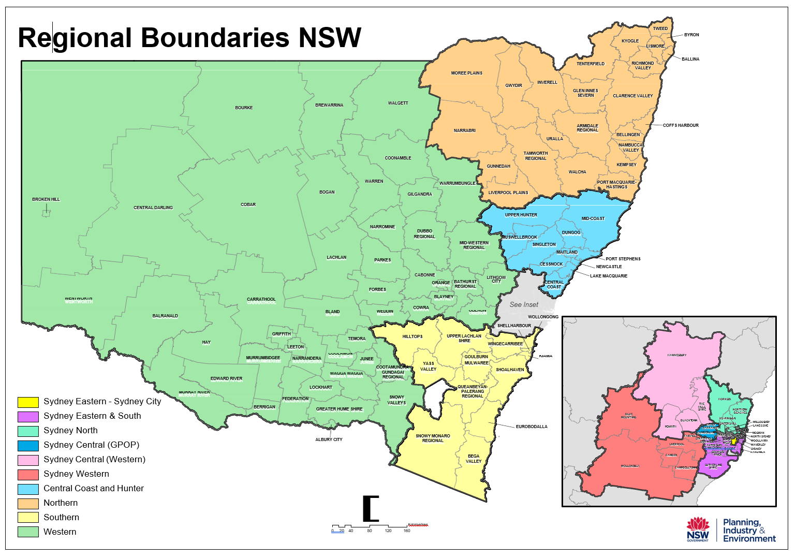
APPENDIX D
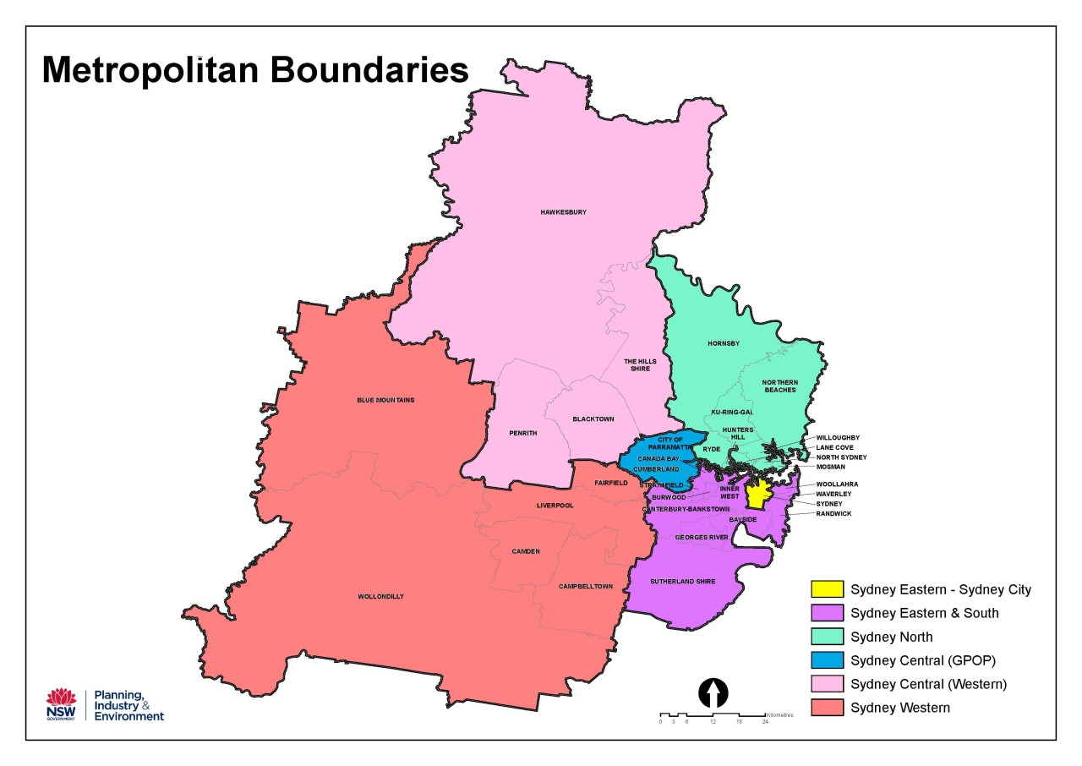
APPENDIX D
The Cabinet Office

52 Martin Place
Sydney NSW 2000

GPO Box 5341
Sydney NSW 2001

Office hours:
Monday to Friday
9.00am – 5.00pm

E: WNSWGrants@tco.nsw.gov.au
W: https://www.nsw.gov.au/women-nsw

